Freeform Open Curves
# Source: AI Source: Provided by: [Data Path: Persons Table -> ID Column: 1, Name_En Column: Motasem Essam] -> From: [ChatGPT] on [7/25/2026]
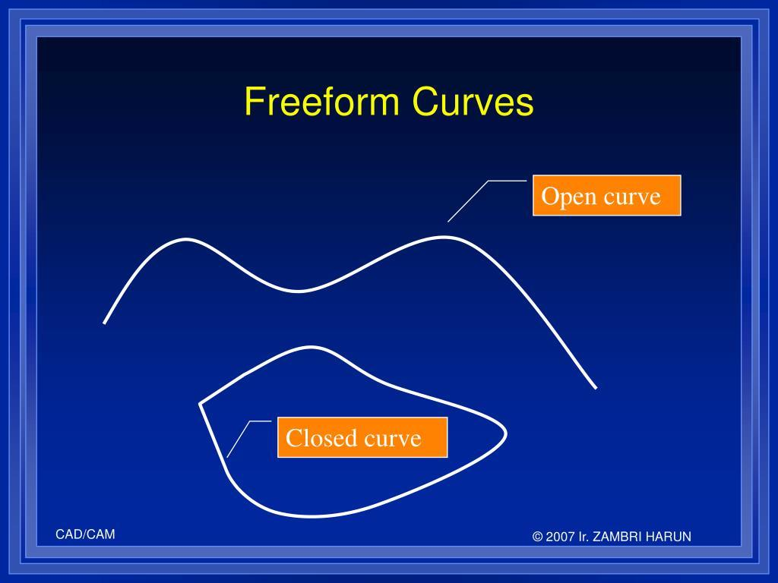
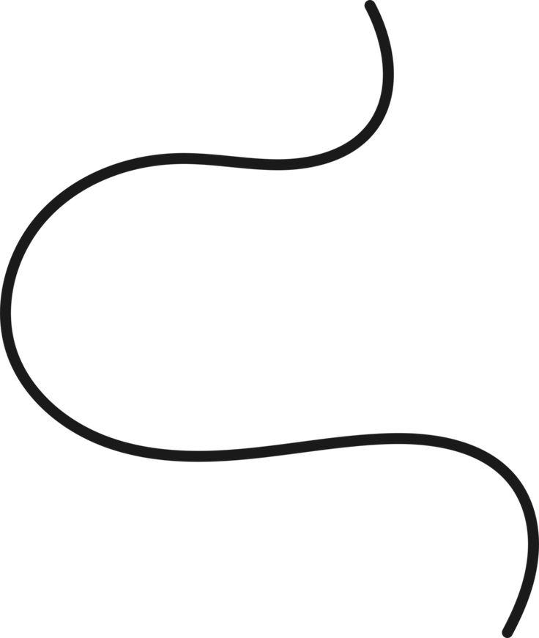
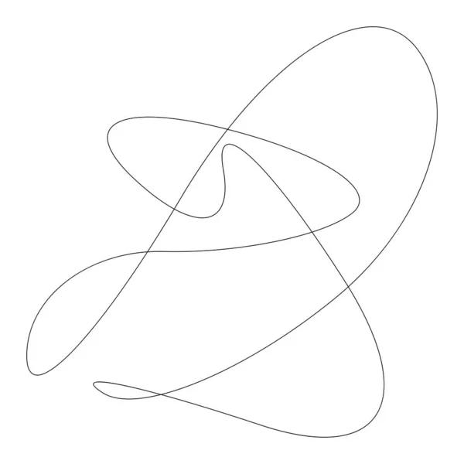
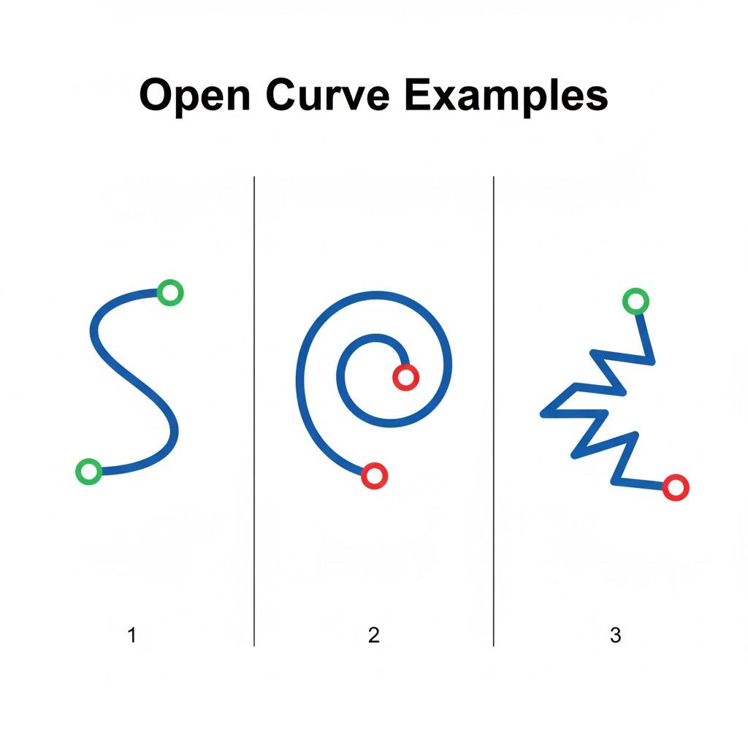
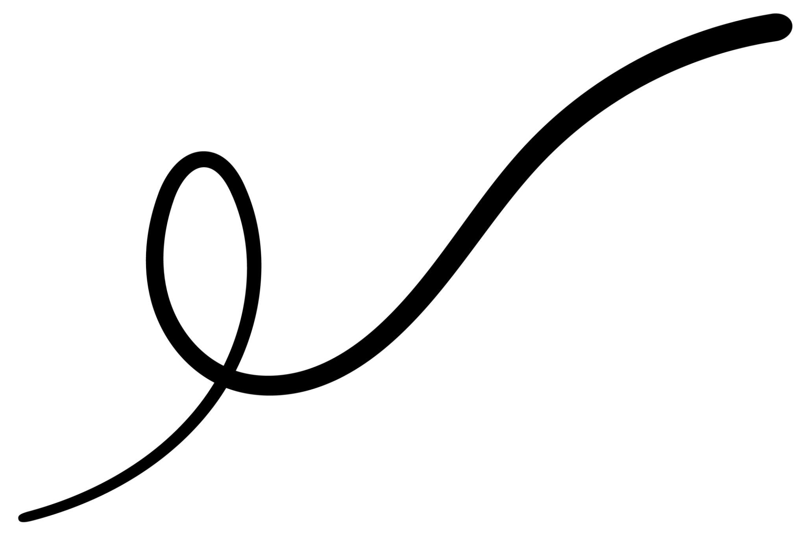
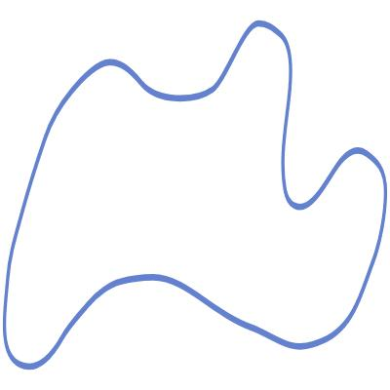

Definition
# Source: AI Source: Provided by: [Data Path: Persons Table -> ID Column: 1, Name_En Column: Motasem Essam] -> From: [ChatGPT] on [7/25/2026]
A Freeform Open Curve is an open curved shape whose path is freely designed or controlled without being restricted to a standard geometric curve or a fixed mathematical pattern.
$$\boxed{\text{Freeform Open Curve}=\text{Open}+\text{Curved}+\text{Freely Designed}}$$
It has two distinct endpoints and does not form a closed boundary.

Characteristics
# Source: AI Source: Provided by: [Data Path: Persons Table -> ID Column: 1, Name_En Column: Motasem Essam] -> From: [ChatGPT] on [7/25/2026]
A Freeform Open Curve:
- Is open.
- Has two distinct endpoints.
- Is primarily curved.
- Does not need to follow a circle, ellipse, parabola, or hyperbola.
- May have changing curvature.
- May be smooth or irregular.
- May be symmetric or asymmetric.
- Can be designed artificially or artistically.
- Does not enclose an area by itself.
- Can be used as part of a larger shape or drawing.

Types of Freeform Open Curves

1. Simple Freeform Open Curve
# Source: AI Source: Provided by: [Data Path: Persons Table -> ID Column: 1, Name_En Column: Motasem Essam] -> From: [ChatGPT] on [7/25/2026]
A basic freely drawn curved path with no strict geometric pattern.
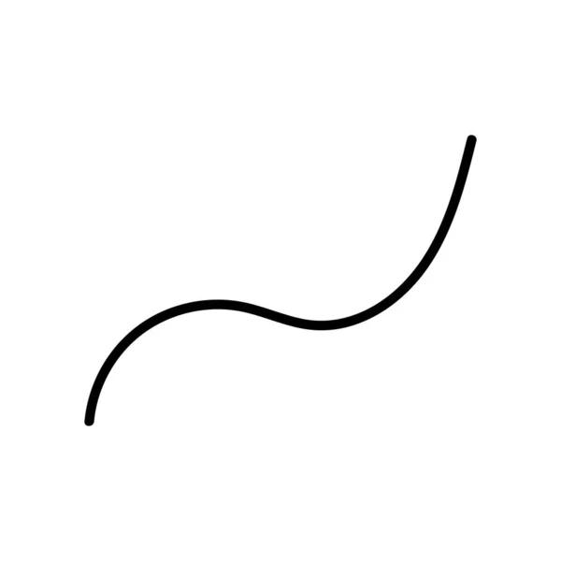
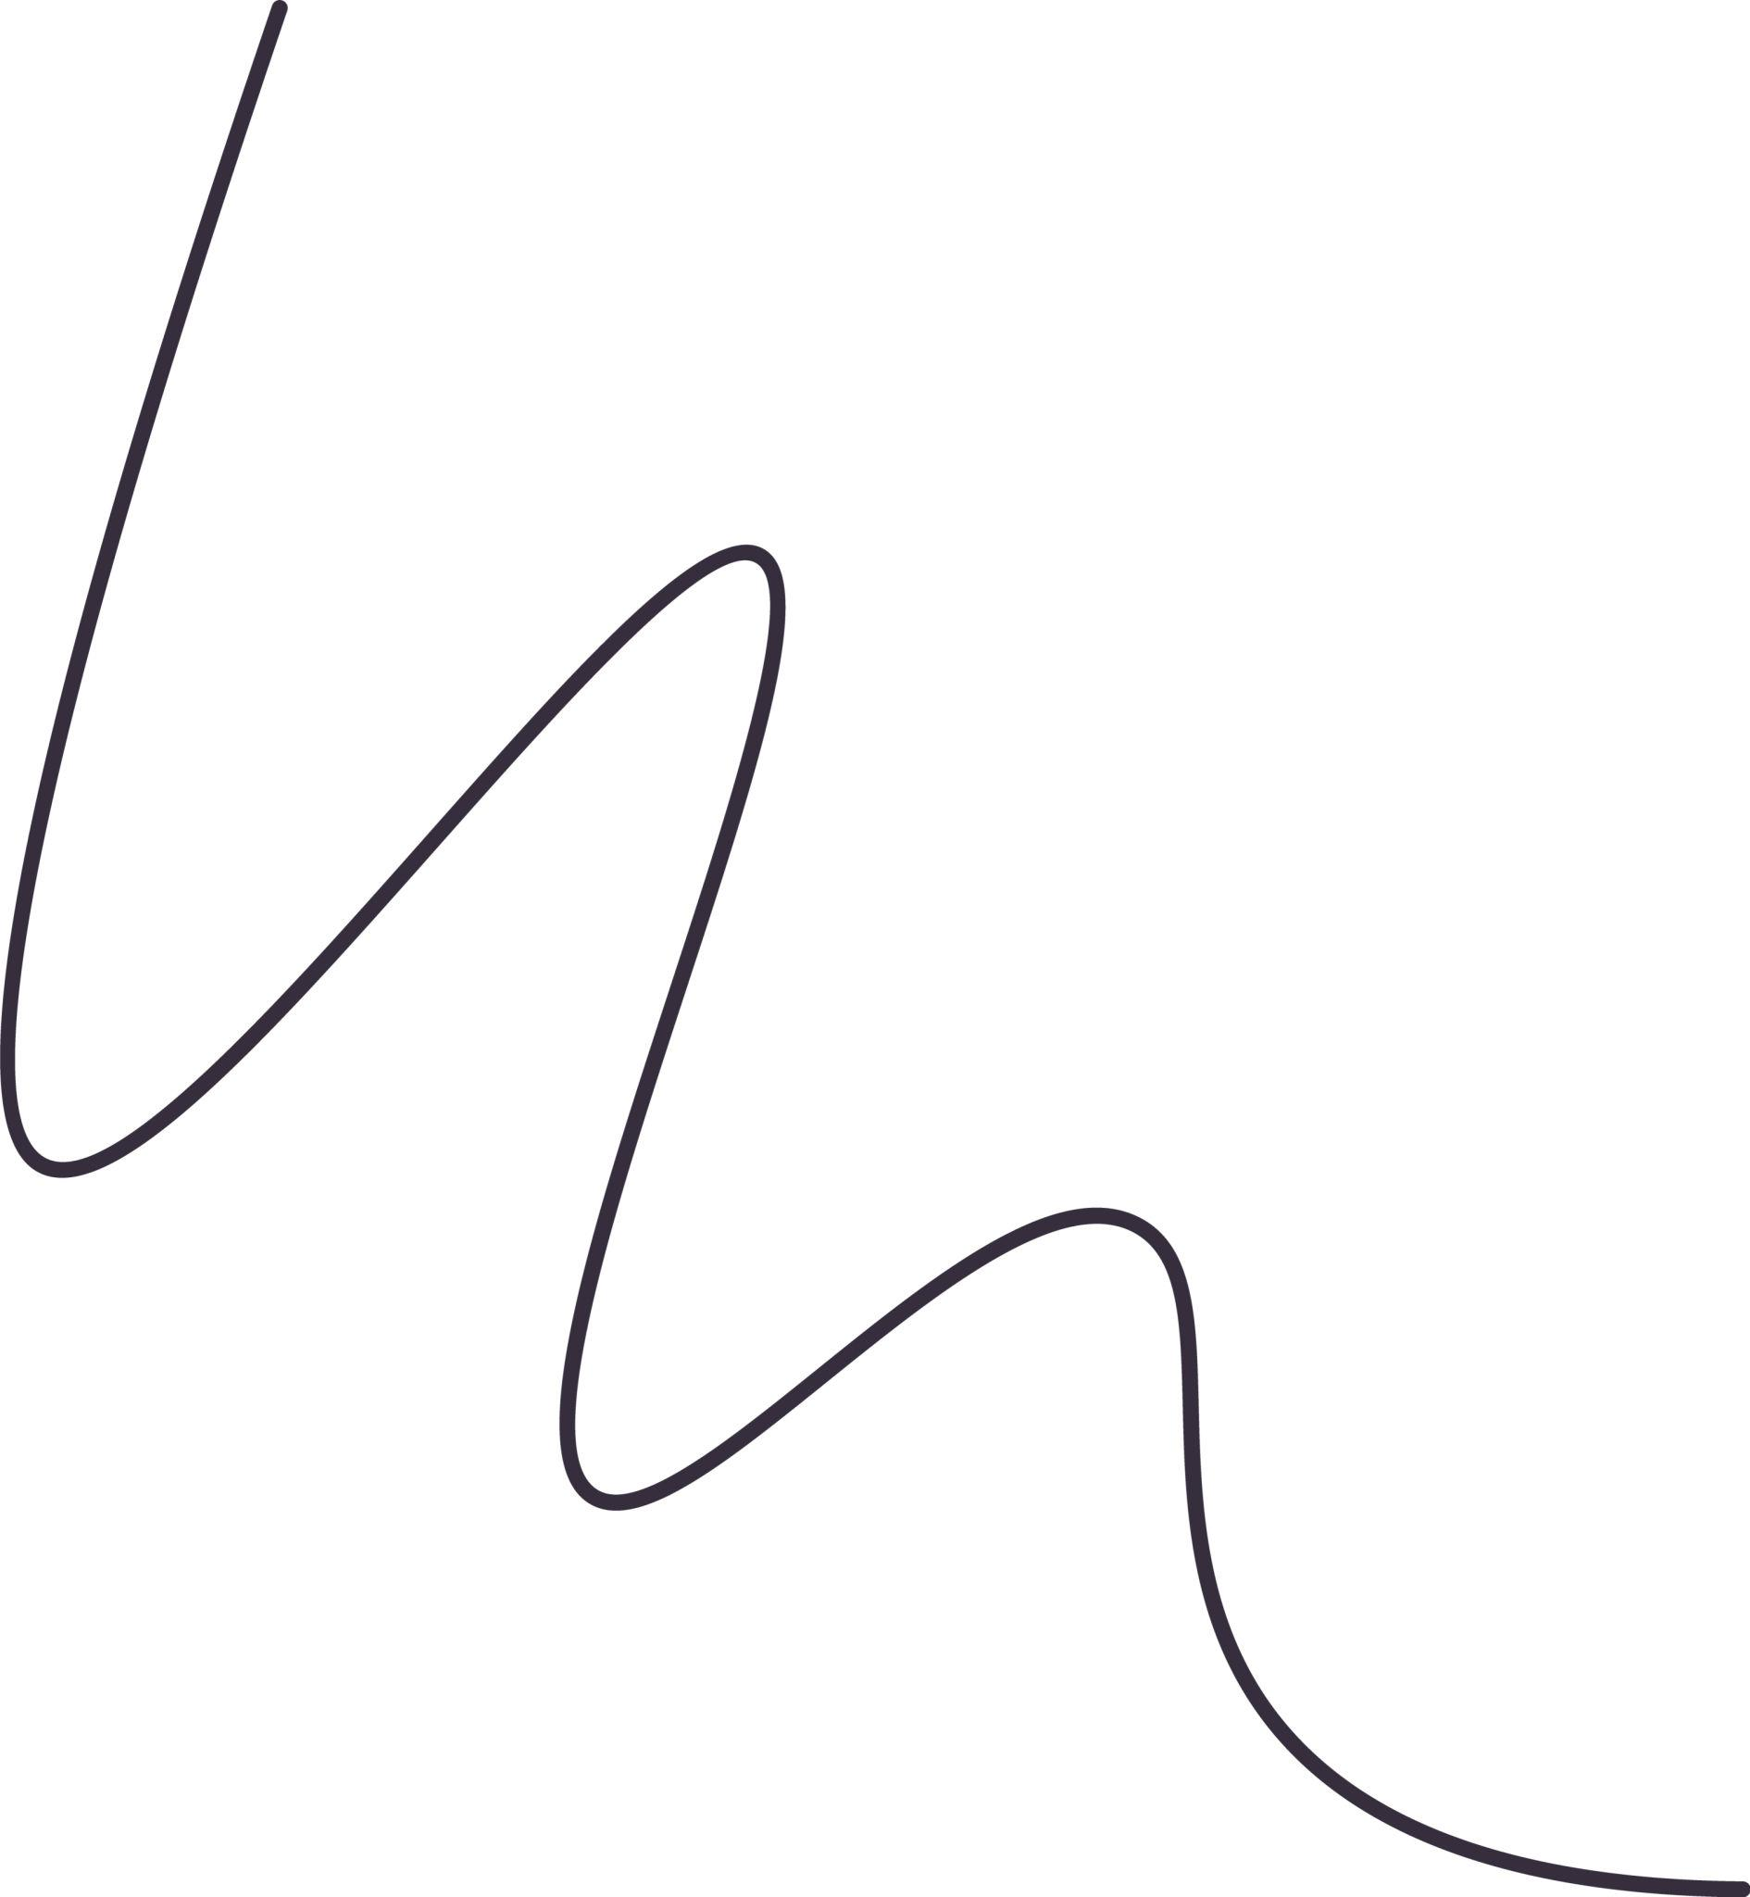
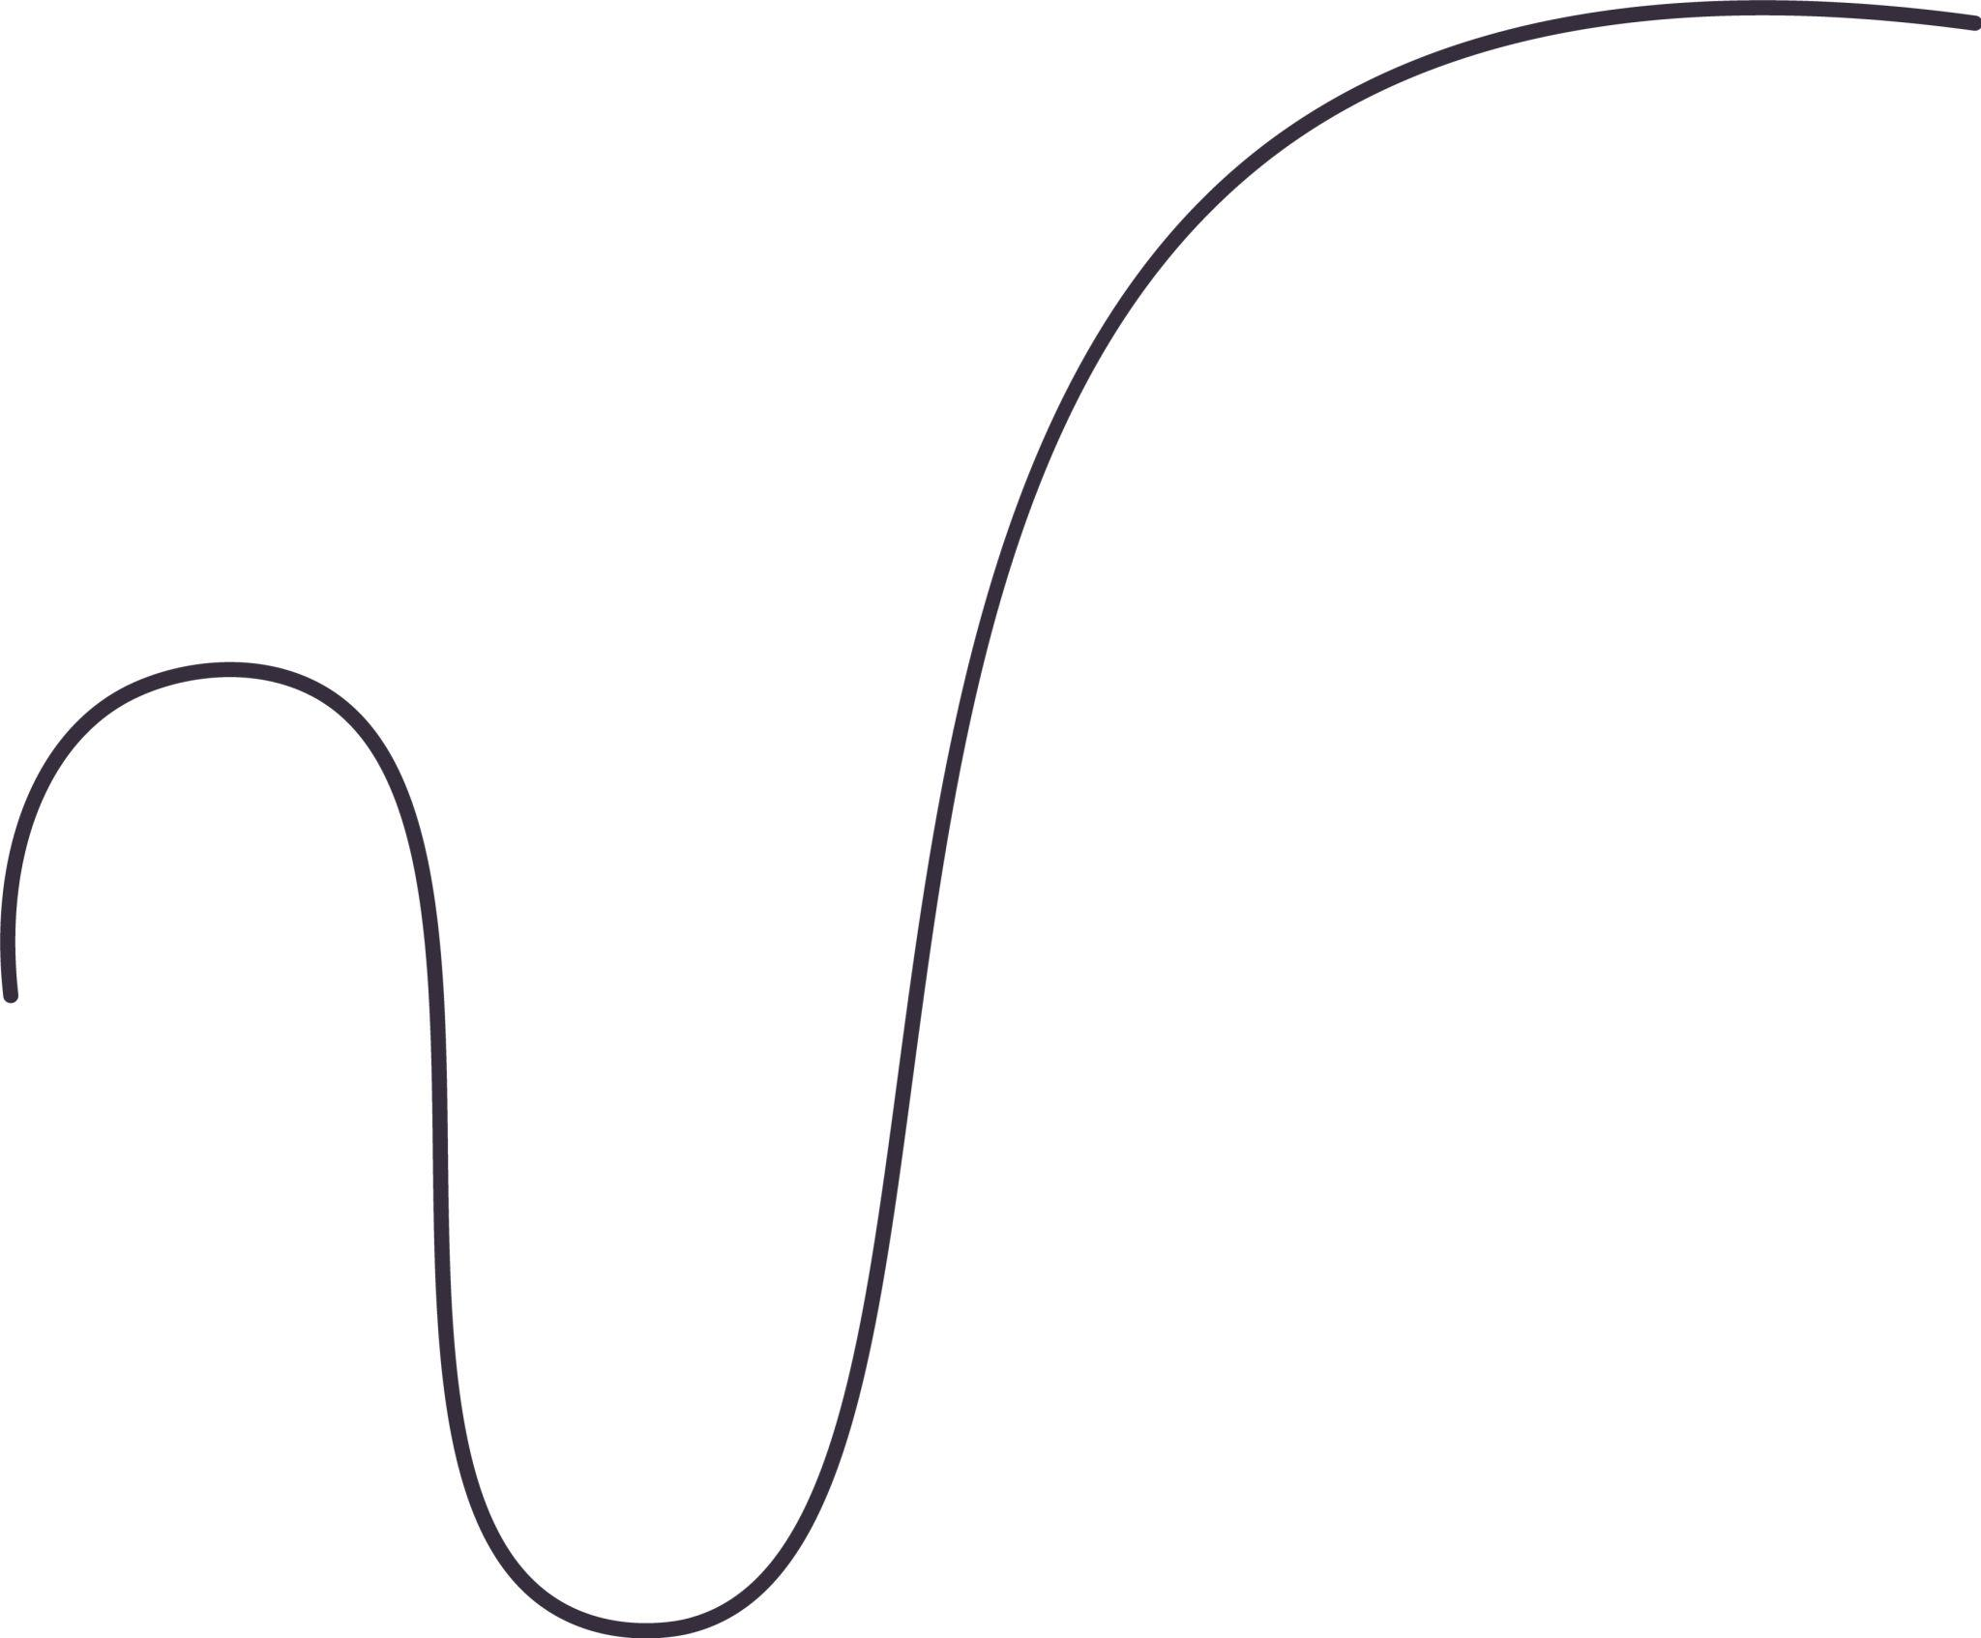
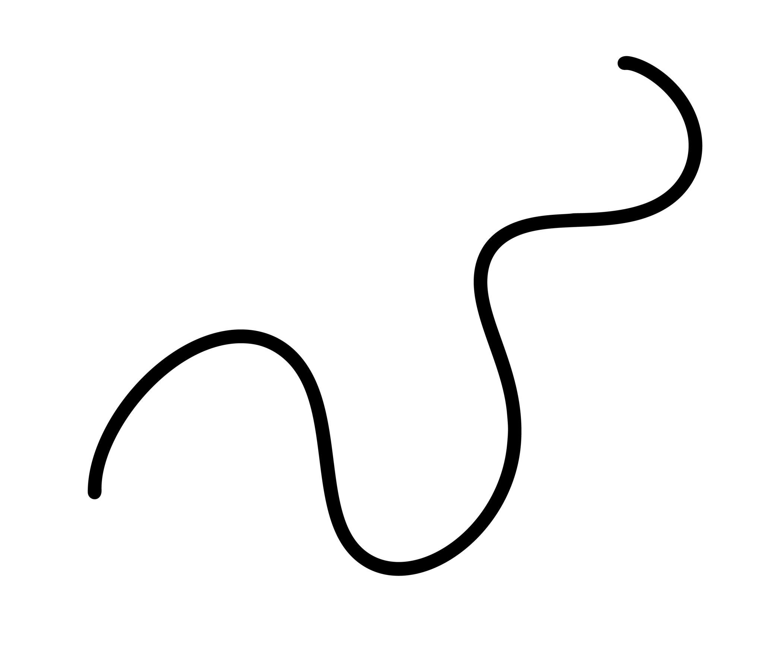
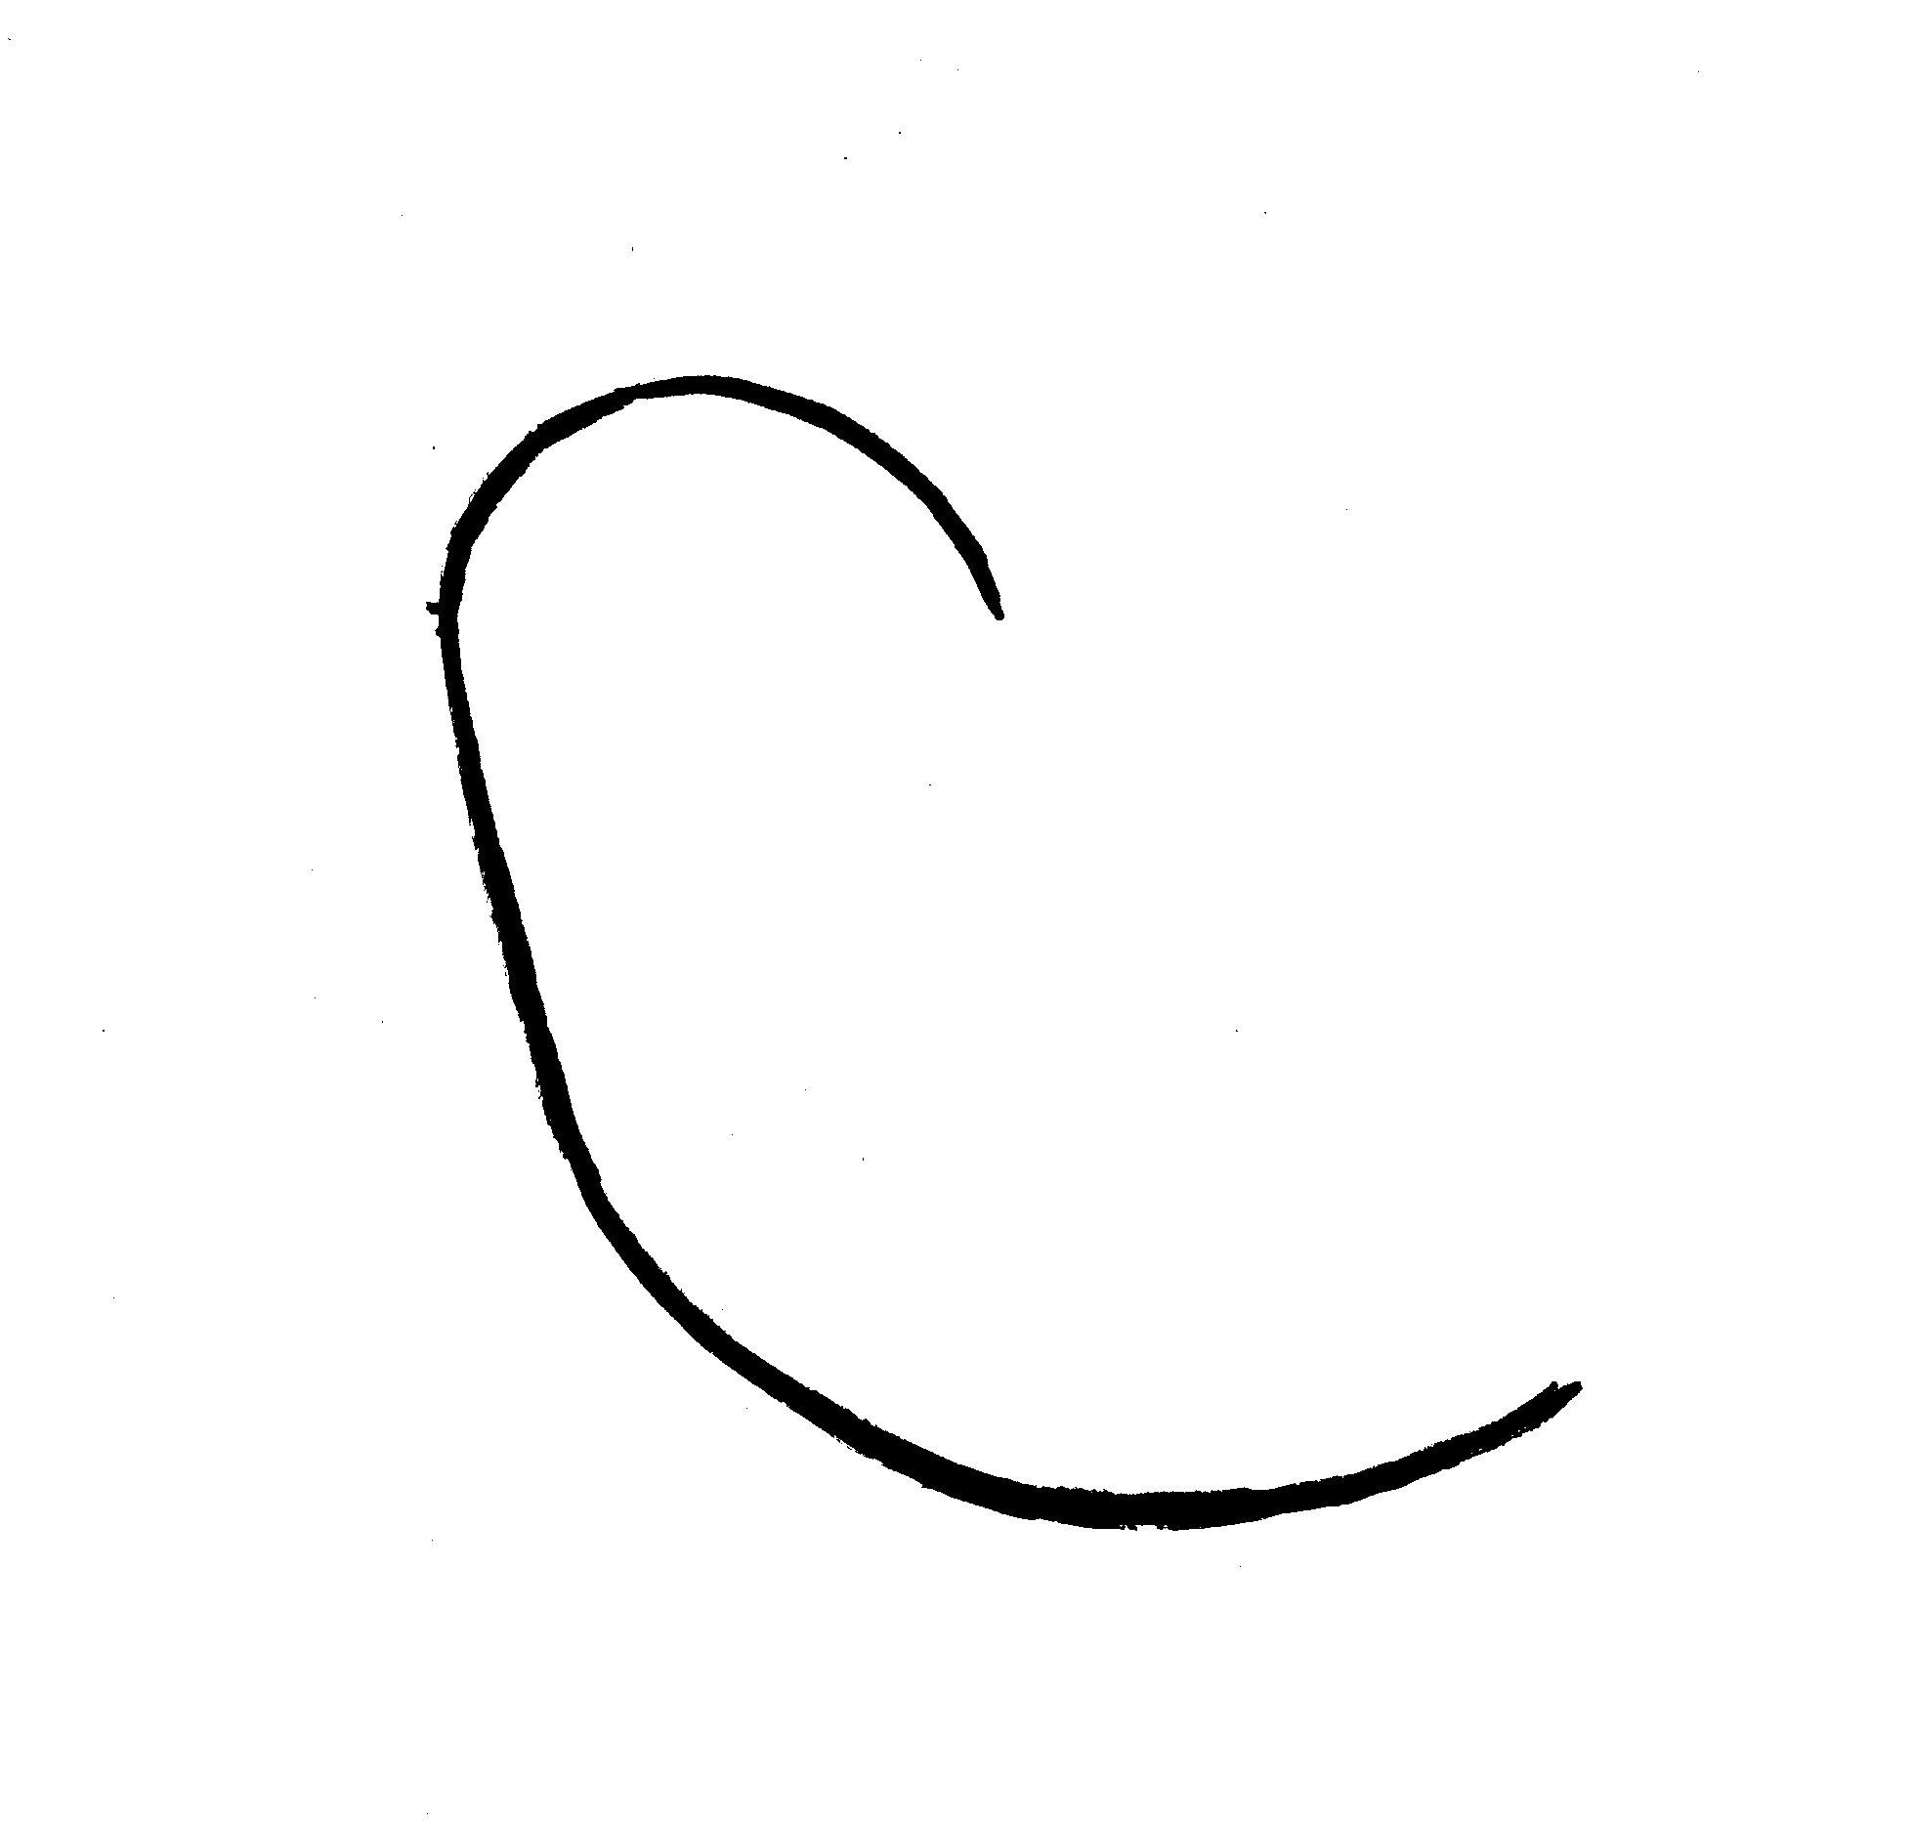
It may contain several changes in direction while remaining visually simple.

2. Smooth Freeform Open Curve
# Source: AI Source: Provided by: [Data Path: Persons Table -> ID Column: 1, Name_En Column: Motasem Essam] -> From: [ChatGPT] on [7/25/2026]
A freeform curve with gradual changes in direction and no sharp corners.
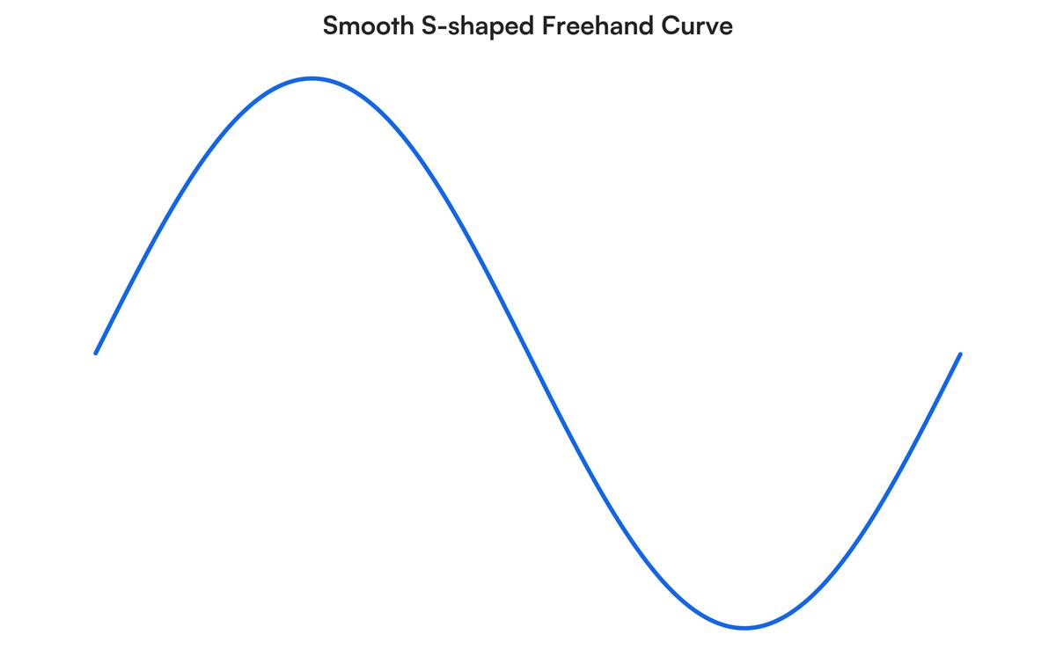
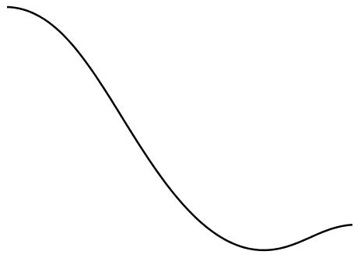
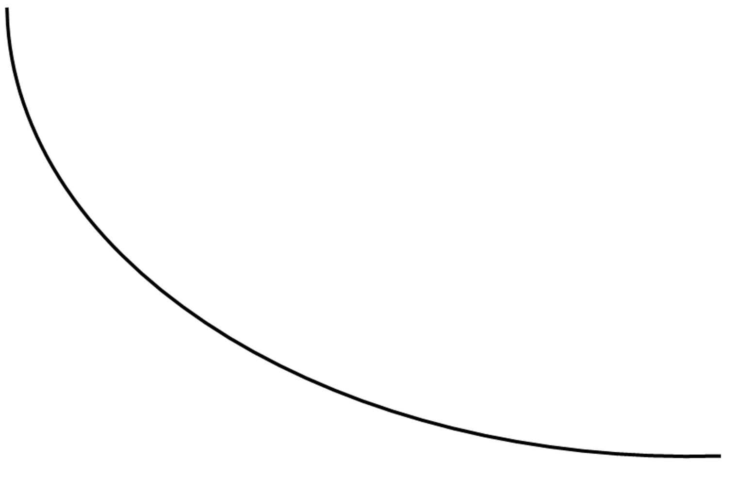
This type is common in digital drawing and graphic design.

3. Irregular Freeform Open Curve
# Source: AI Source: Provided by: [Data Path: Persons Table -> ID Column: 1, Name_En Column: Motasem Essam] -> From: [ChatGPT] on [7/25/2026]
A freely designed curve with uneven curvature and no repeating geometric pattern.
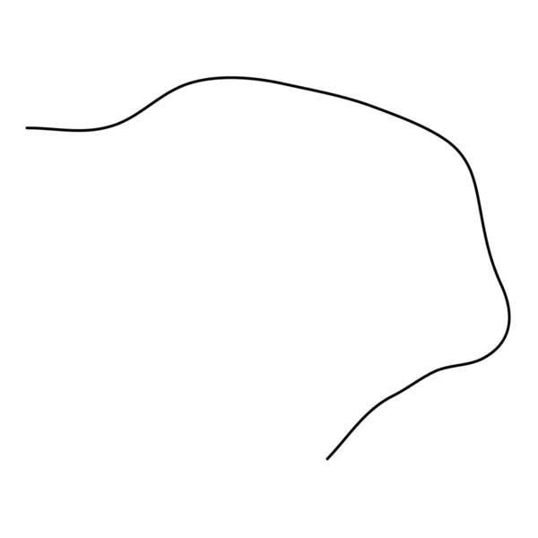
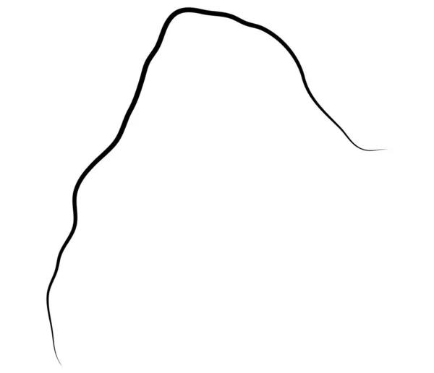
Its defining feature is the lack of a standard geometric structure.

4. Wavy Freeform Open Curve
# Source: AI Source: Provided by: [Data Path: Persons Table -> ID Column: 1, Name_En Column: Motasem Essam] -> From: [ChatGPT] on [7/25/2026]
A freely designed curve containing several waves or undulations.
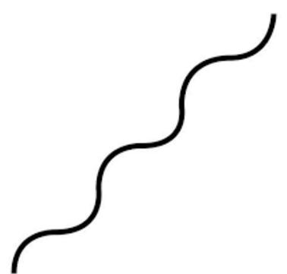
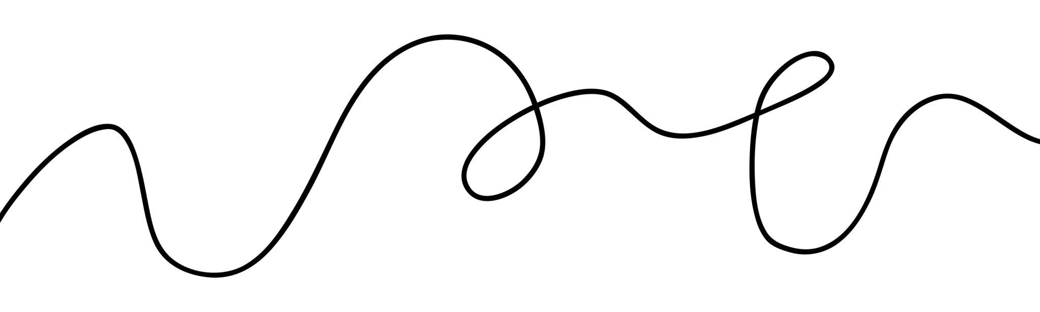
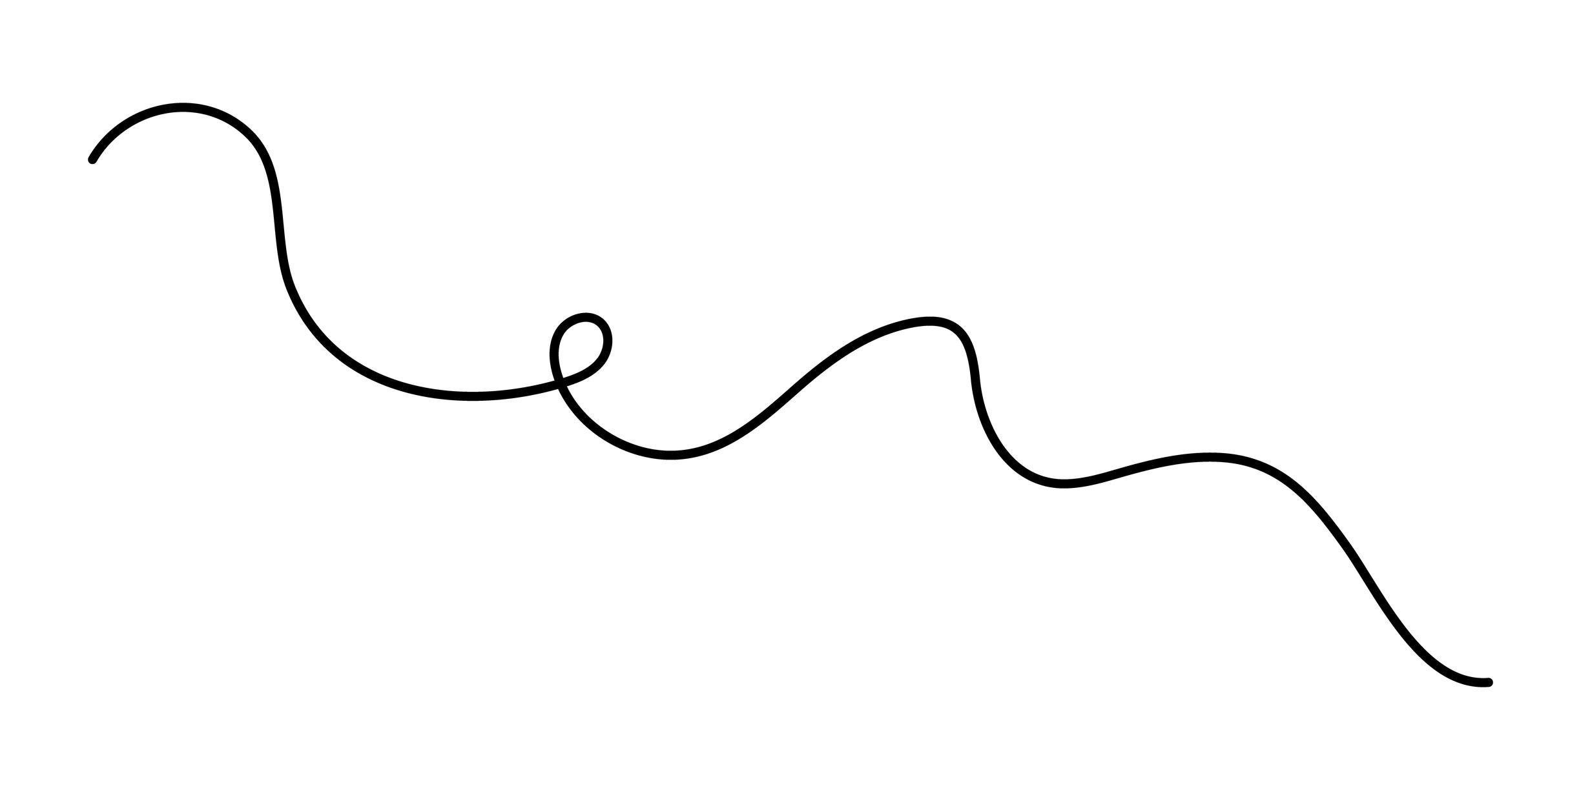
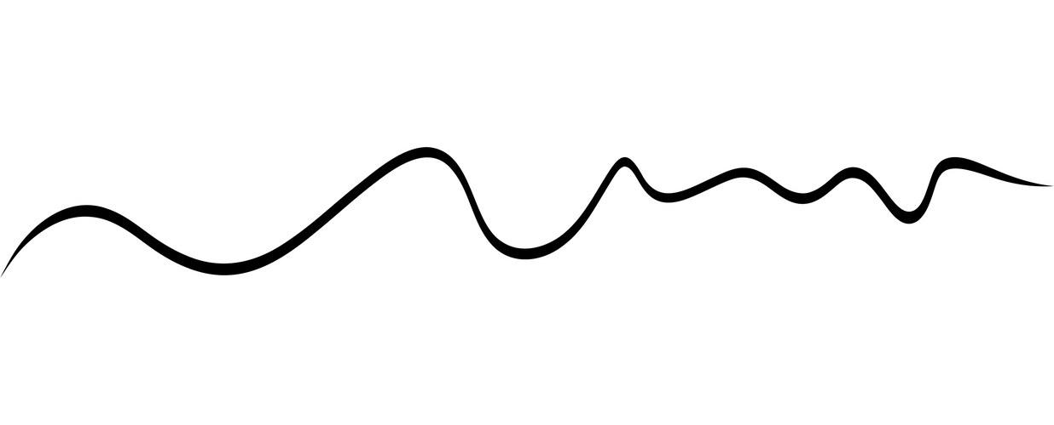
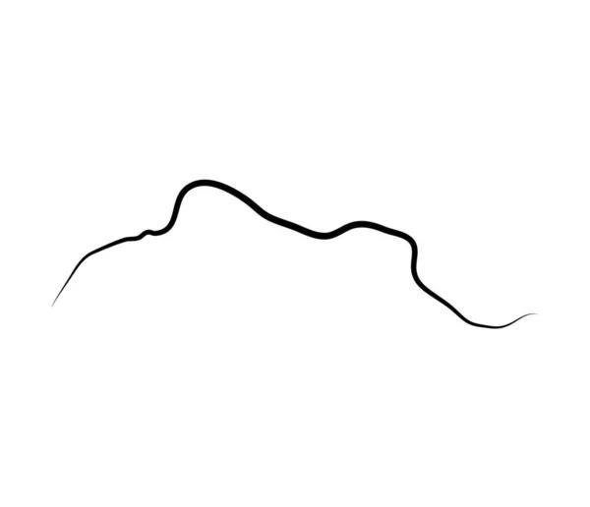
Unlike a mathematical sine wave, its waves do not need to have equal amplitude or wavelength.

5. Spiral-Like Freeform Open Curve
# Source: AI Source: Provided by: [Data Path: Persons Table -> ID Column: 1, Name_En Column: Motasem Essam] -> From: [ChatGPT] on [7/25/2026]
A freeform curve that winds around a central region without following a strict spiral equation.
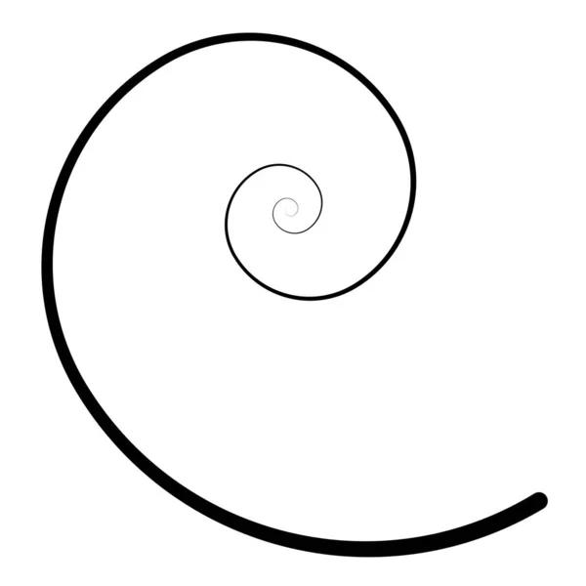
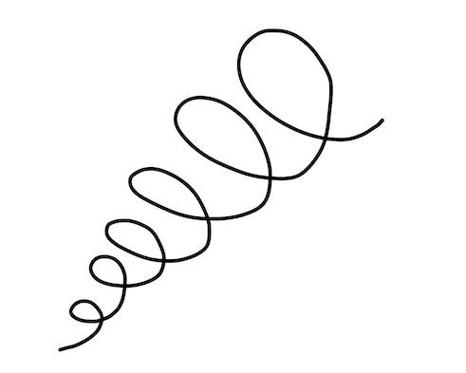
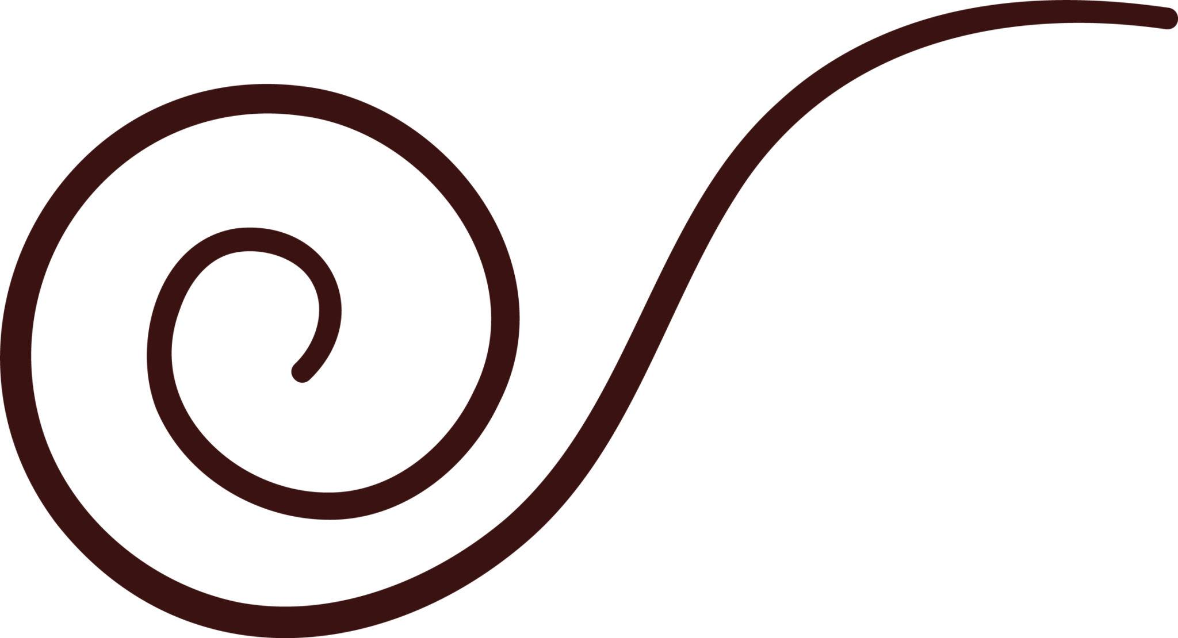
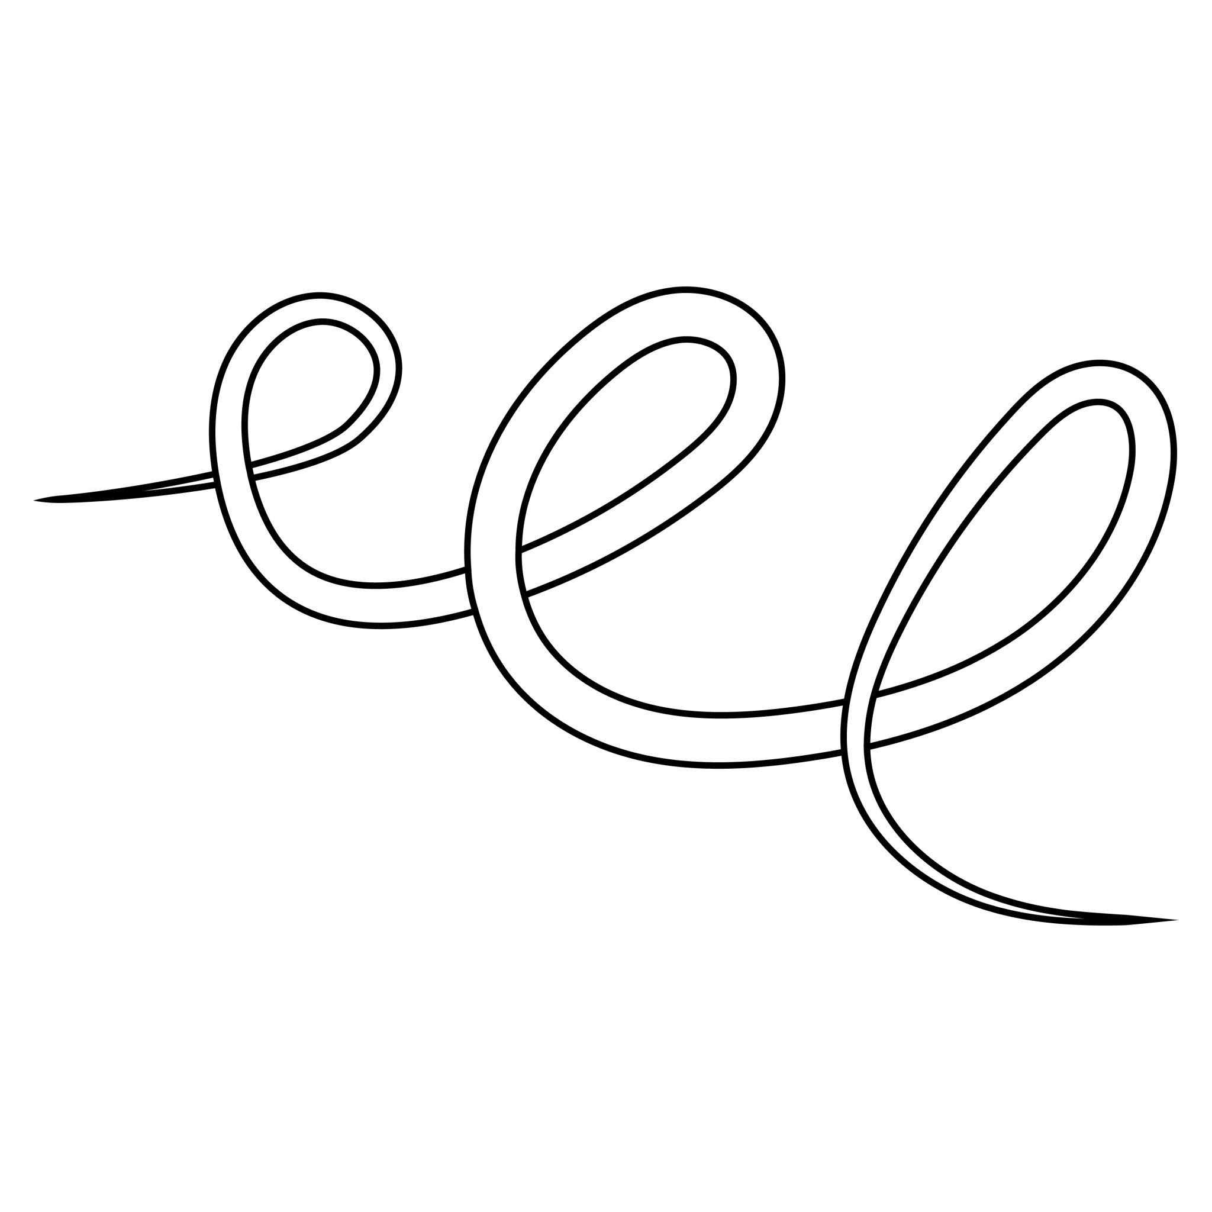
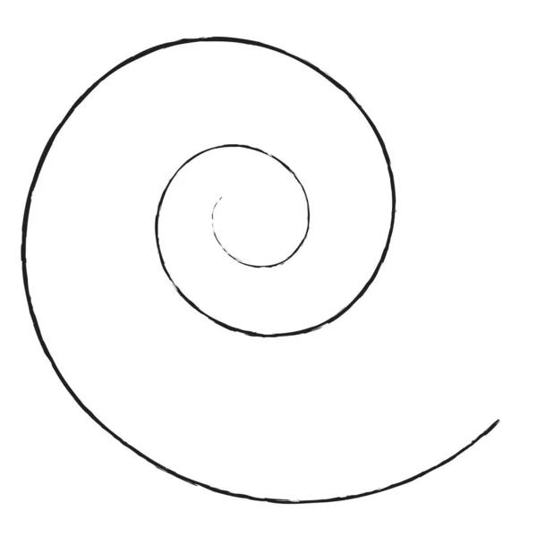
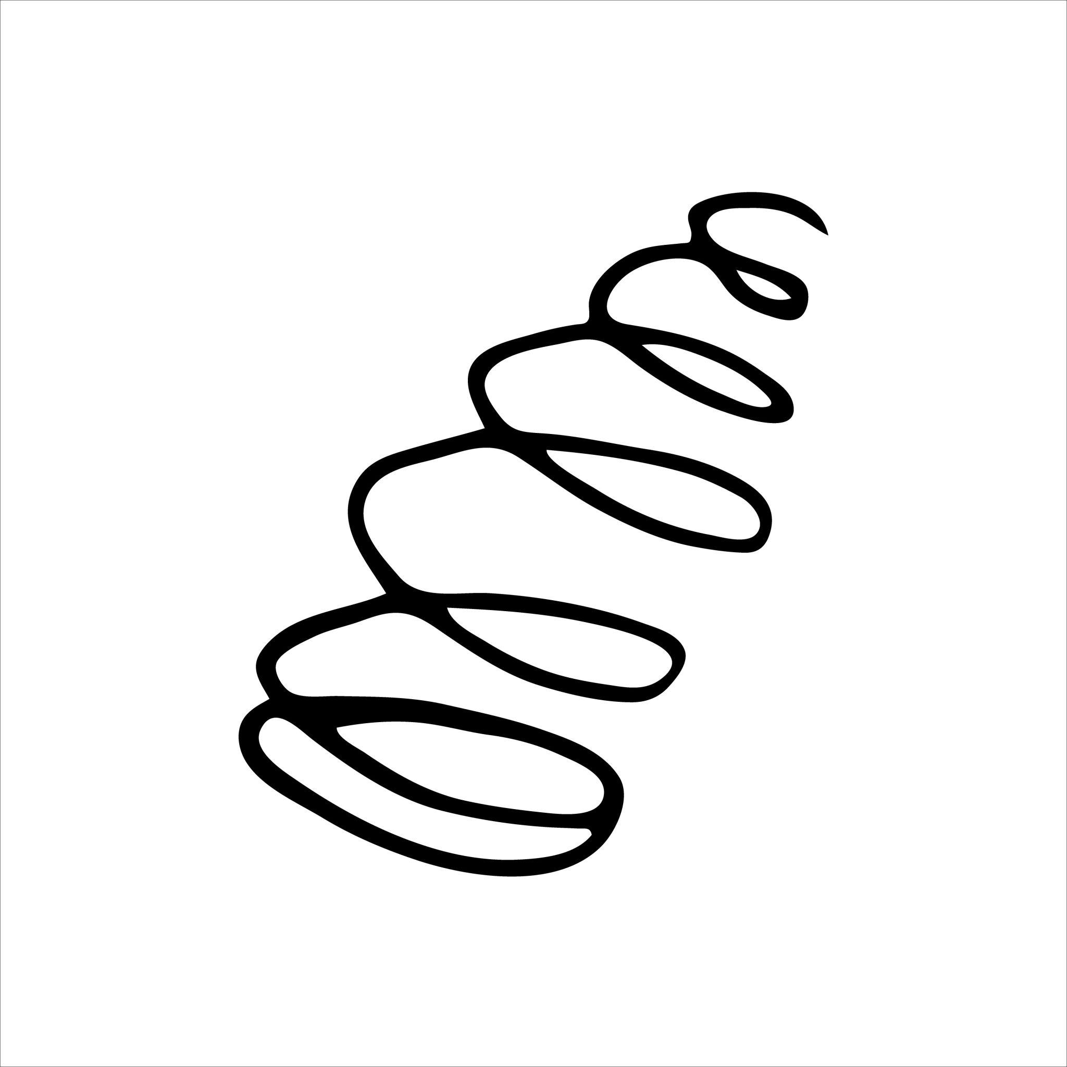
It can resemble a spiral while remaining freely designed.

6. Asymmetric Freeform Open Curve
# Source: AI Source: Provided by: [Data Path: Persons Table -> ID Column: 1, Name_En Column: Motasem Essam] -> From: [ChatGPT] on [7/25/2026]
A freeform curve with no recognizable symmetry.
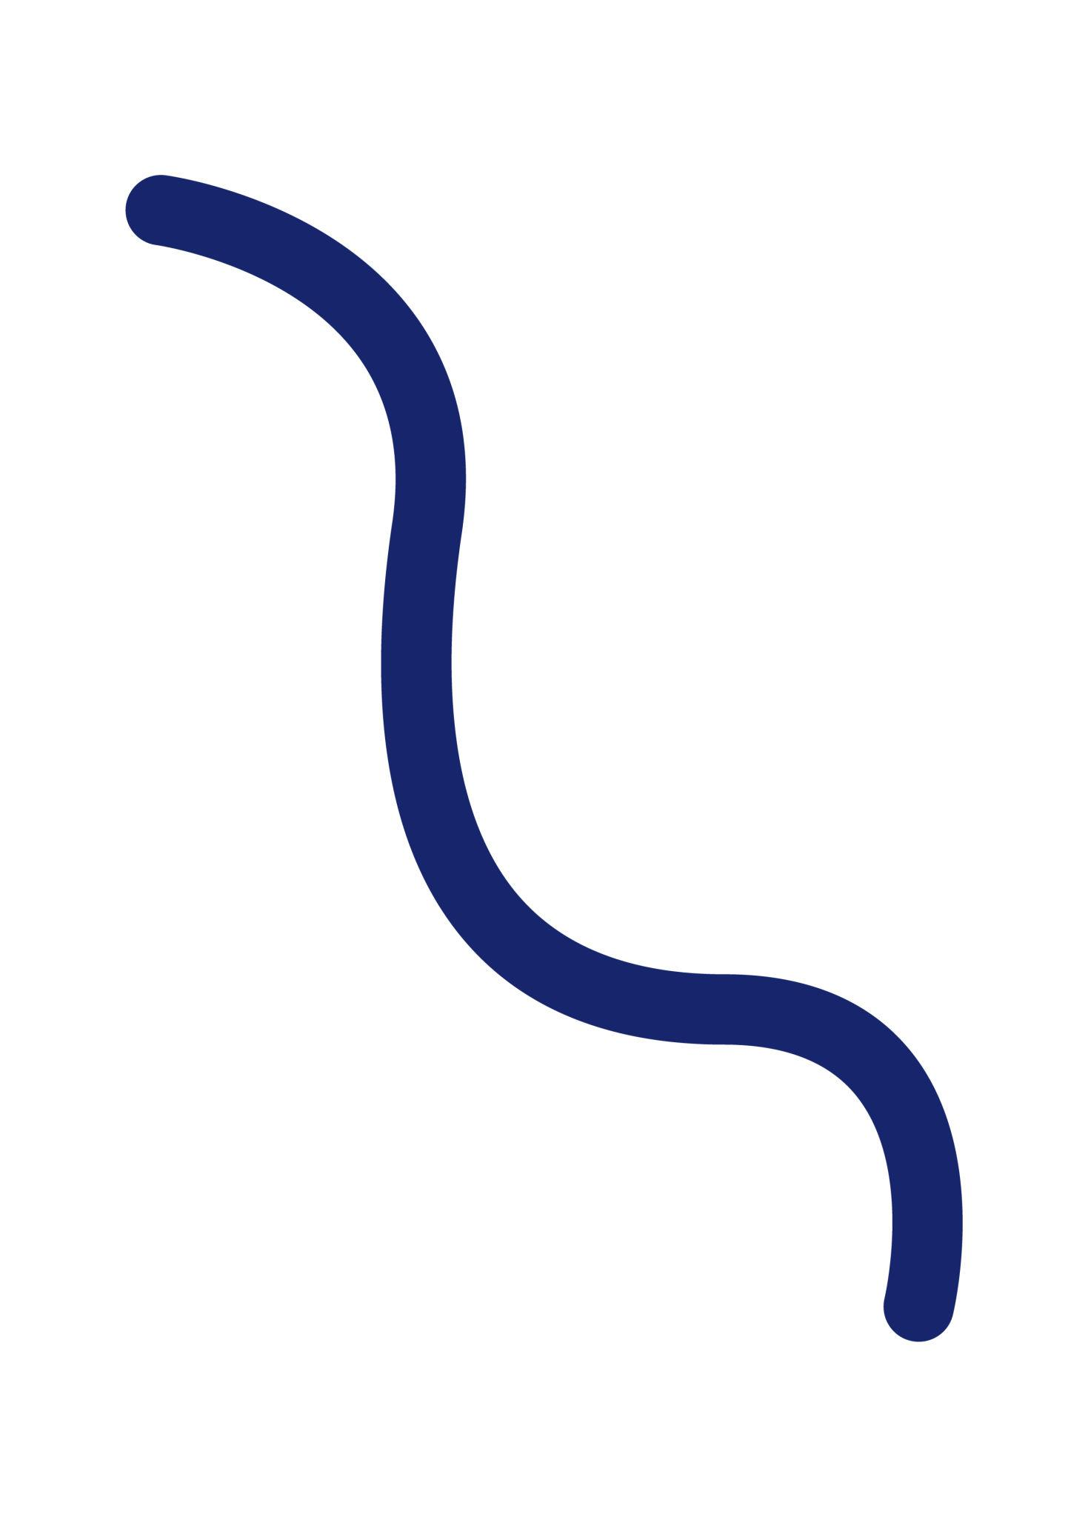
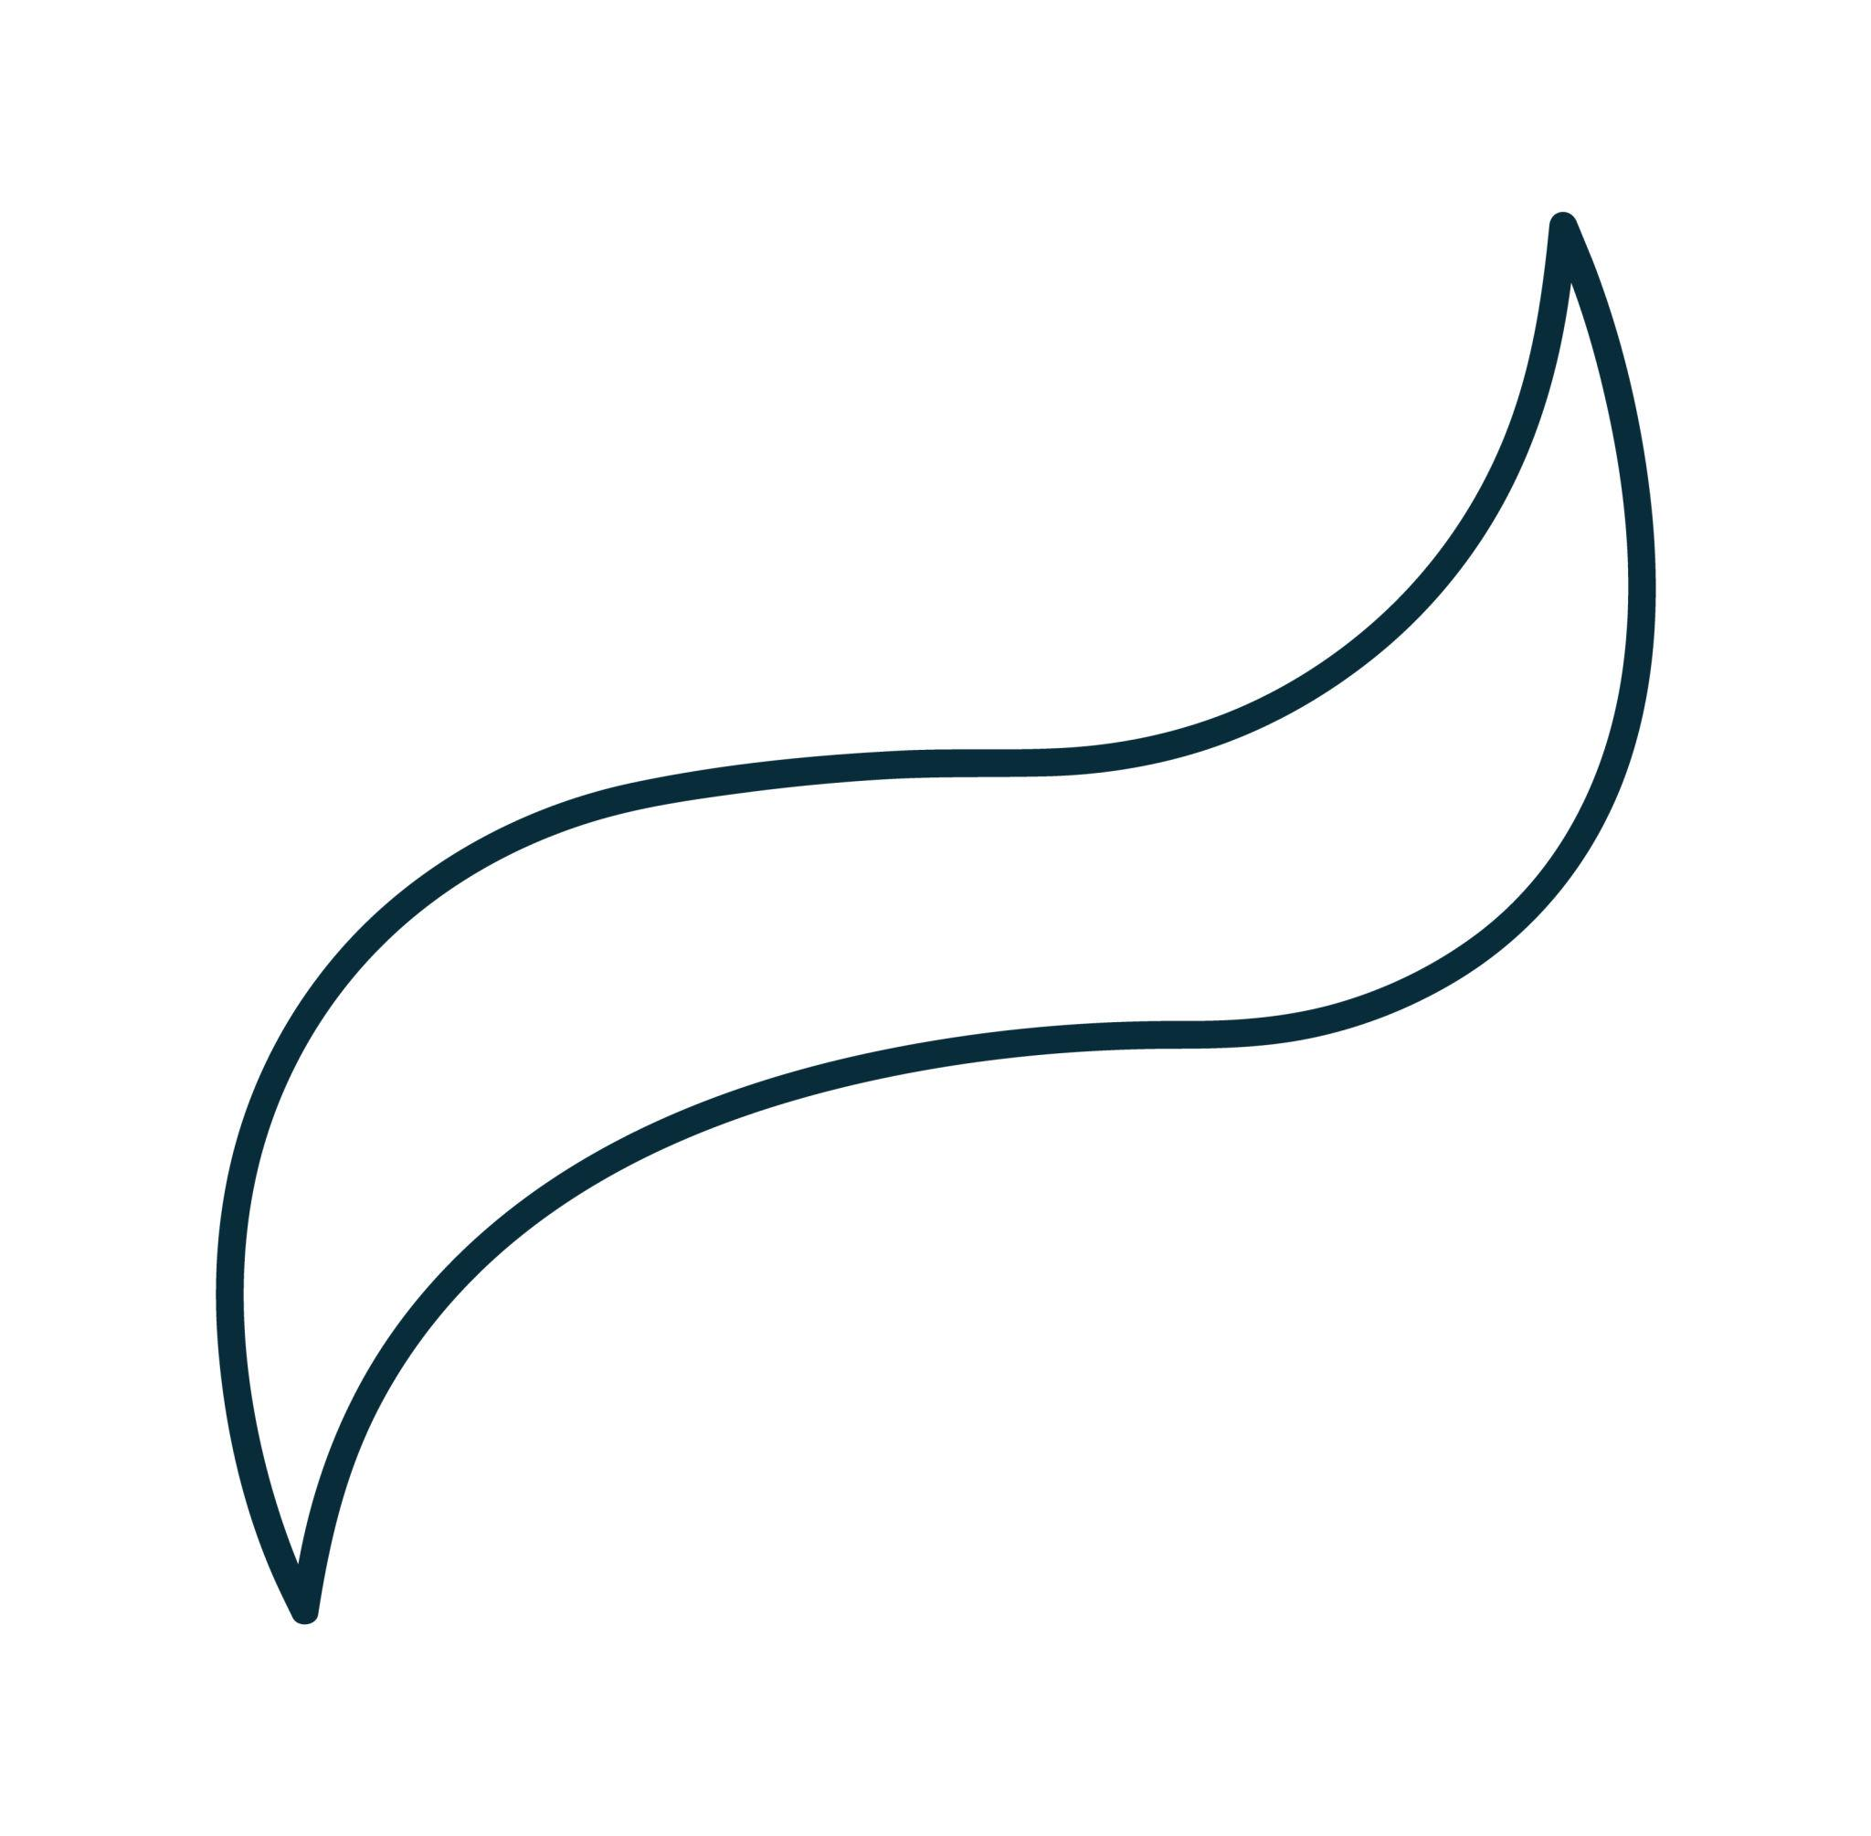
The two sides of the curve can have completely different forms.

7. Symmetric Freeform Open Curve
# Source: AI Source: Provided by: [Data Path: Persons Table -> ID Column: 1, Name_En Column: Motasem Essam] -> From: [ChatGPT] on [7/25/2026]
A freely designed open curve that nevertheless has an axis or point of symmetry.
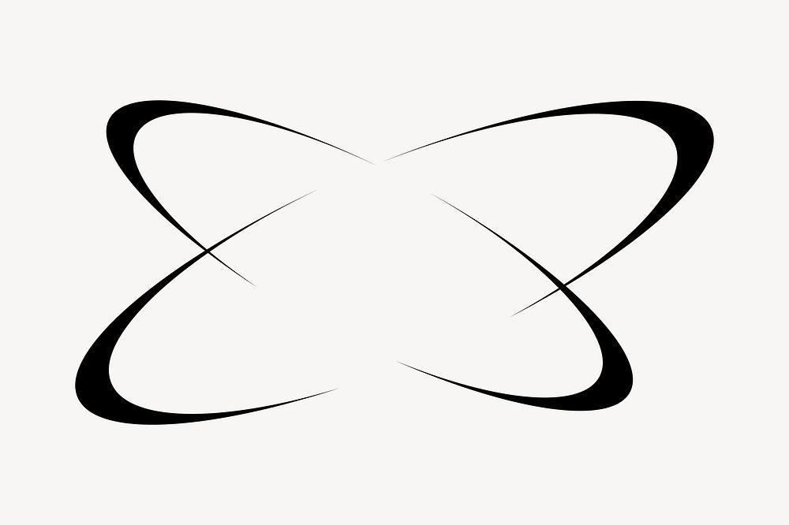
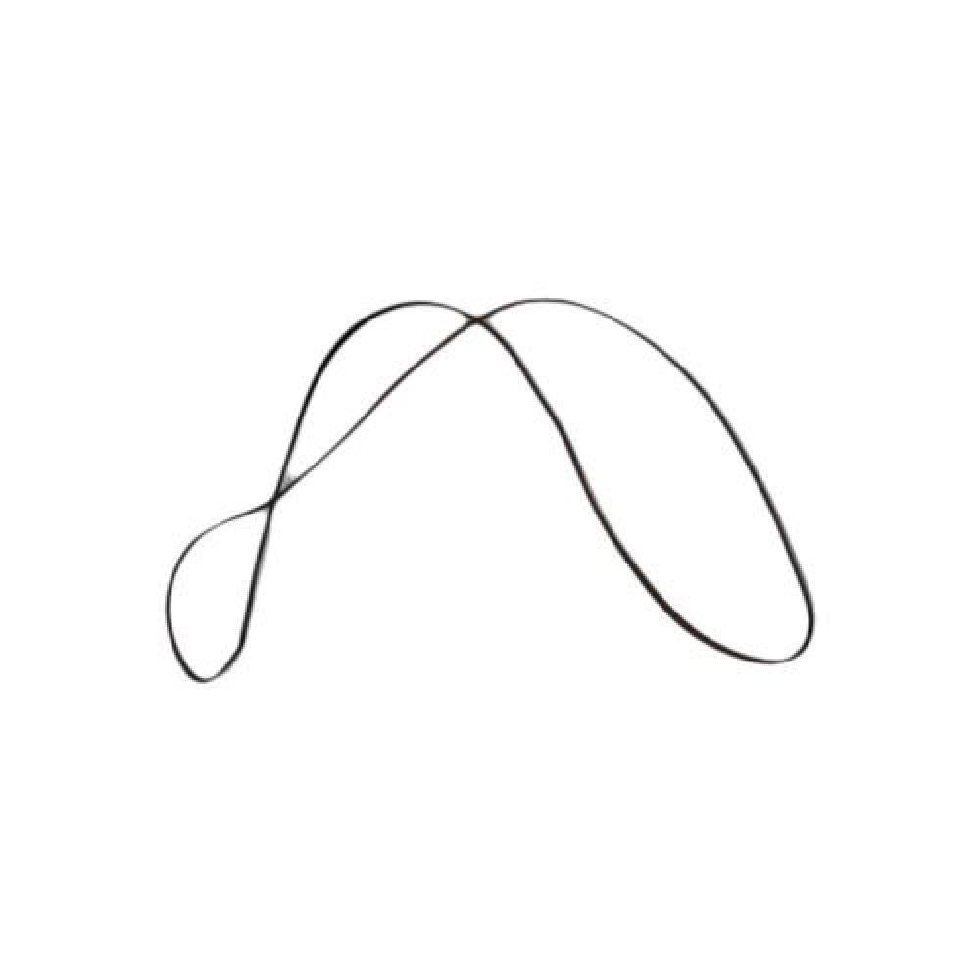
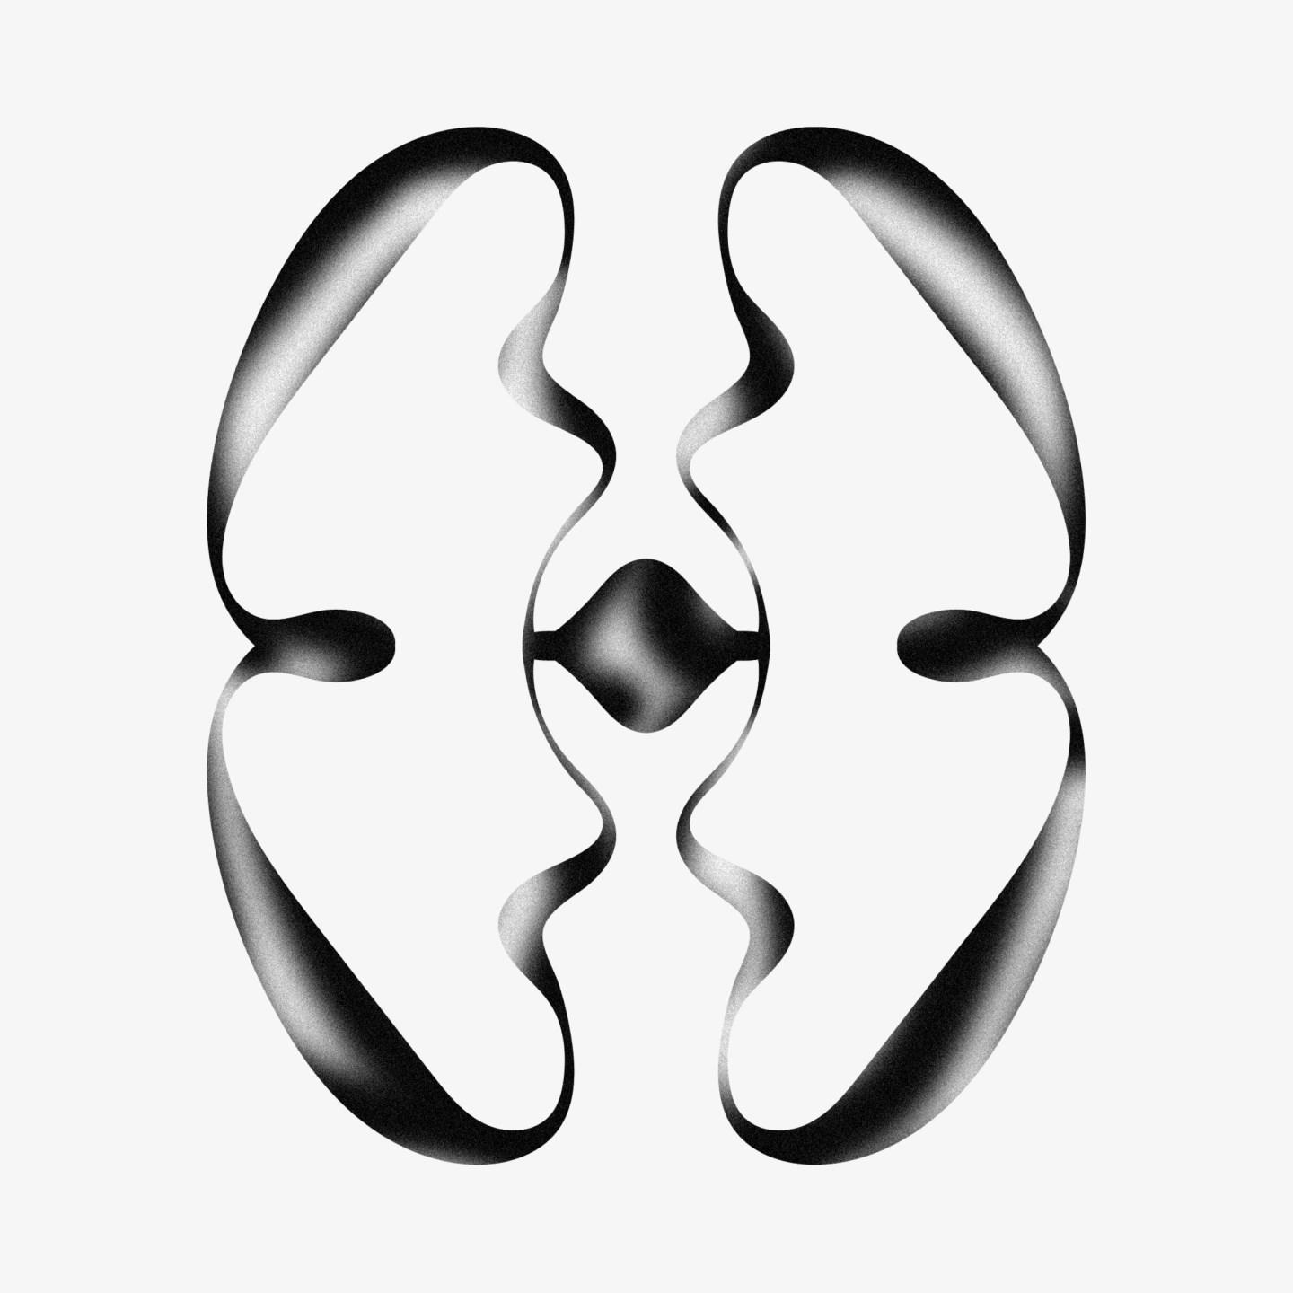
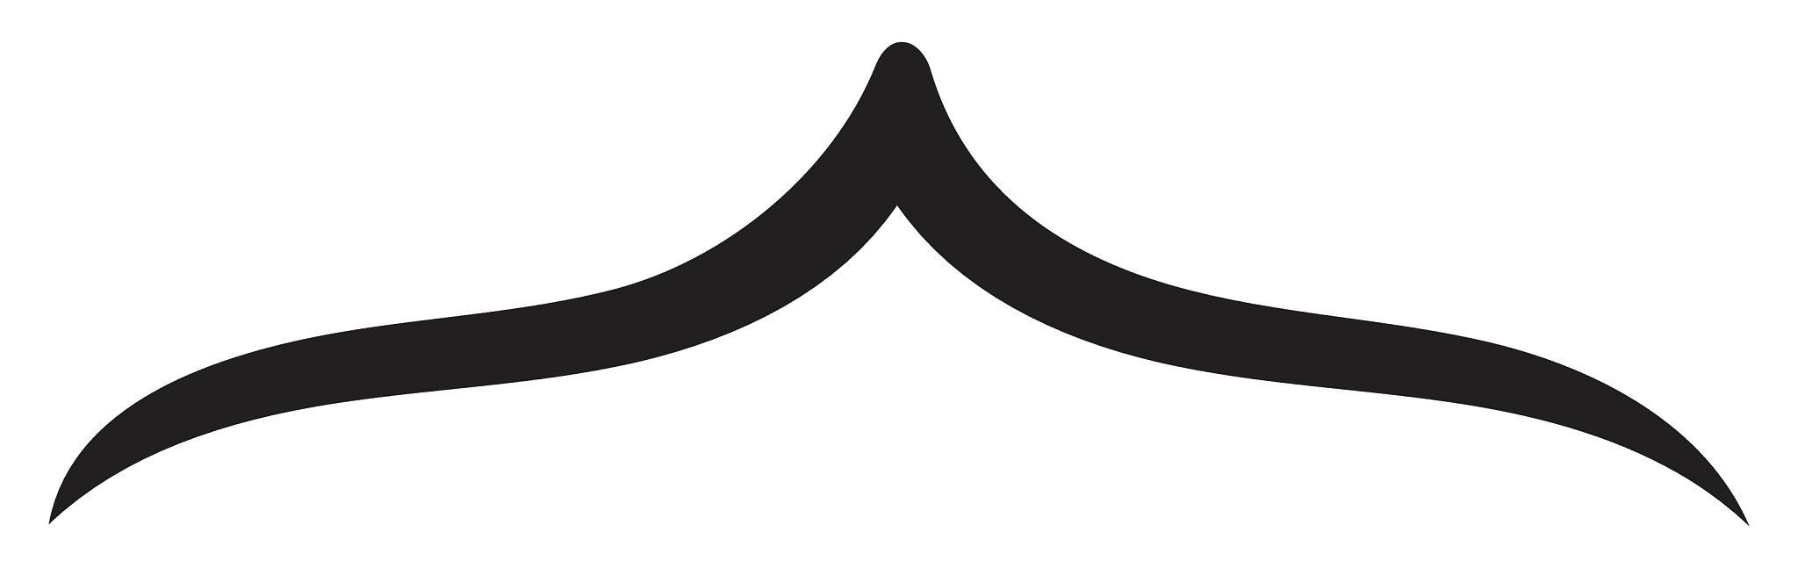
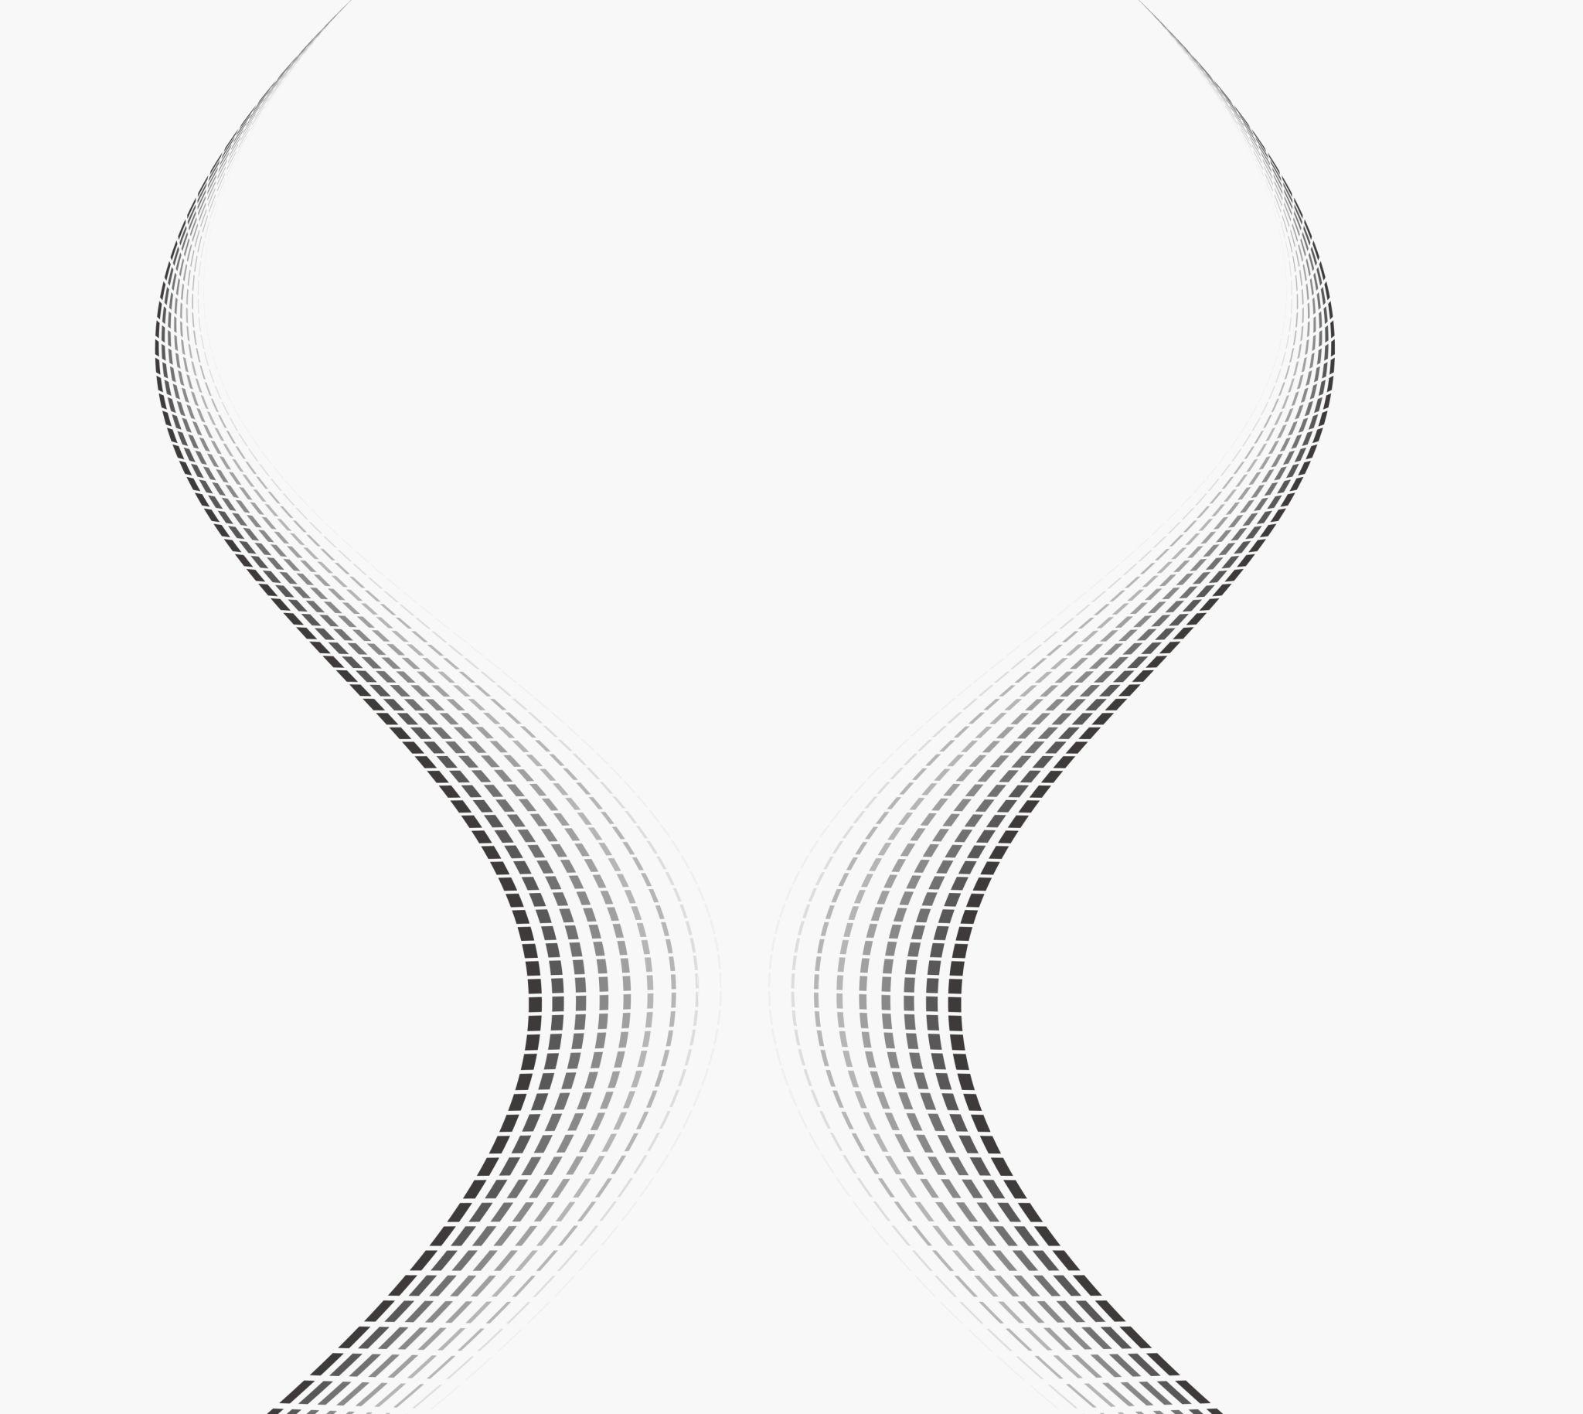
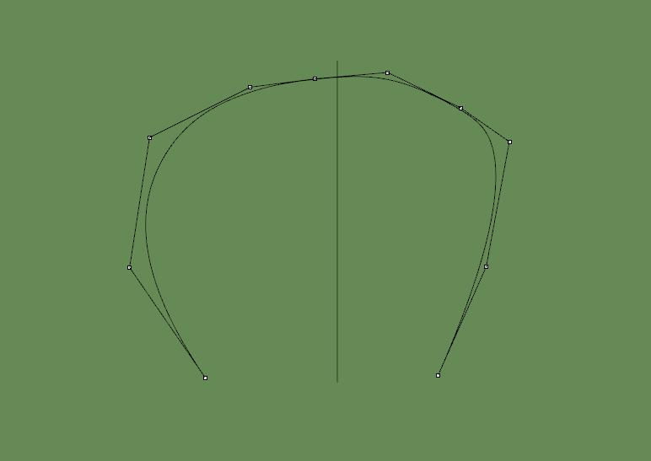
The curve is freeform even though its overall arrangement has symmetry.

8. S-Shaped Freeform Open Curve
# Source: AI Source: Provided by: [Data Path: Persons Table -> ID Column: 1, Name_En Column: Motasem Essam] -> From: [ChatGPT] on [7/25/2026]
A freeform curve resembling the letter S.
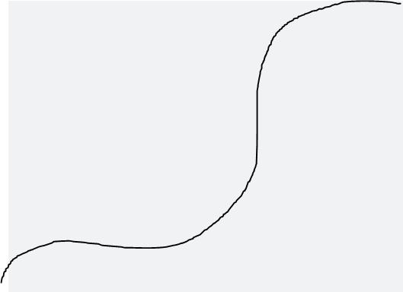
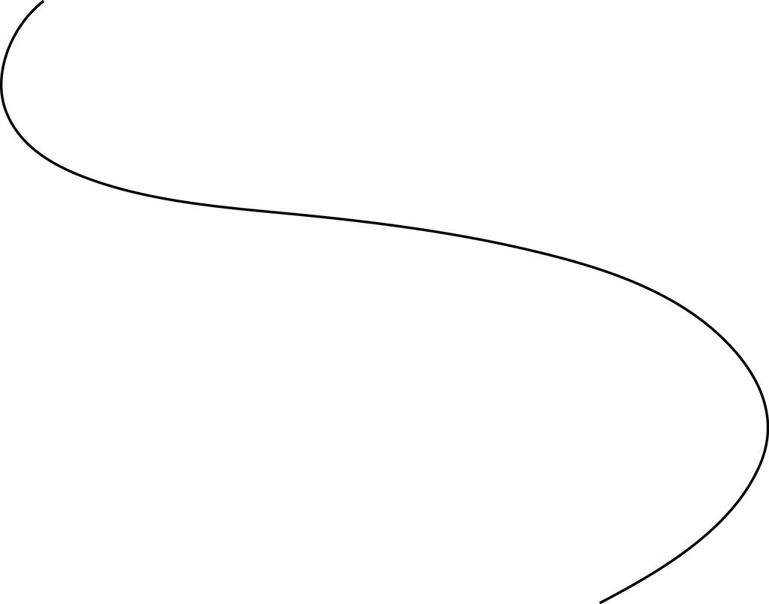
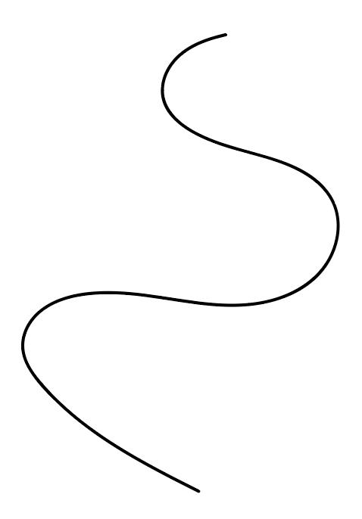
The curve changes its bending direction along its path.

9. C-Shaped Freeform Open Curve
# Source: AI Source: Provided by: [Data Path: Persons Table -> ID Column: 1, Name_En Column: Motasem Essam] -> From: [ChatGPT] on [7/25/2026]
A freely designed curve resembling the letter C.
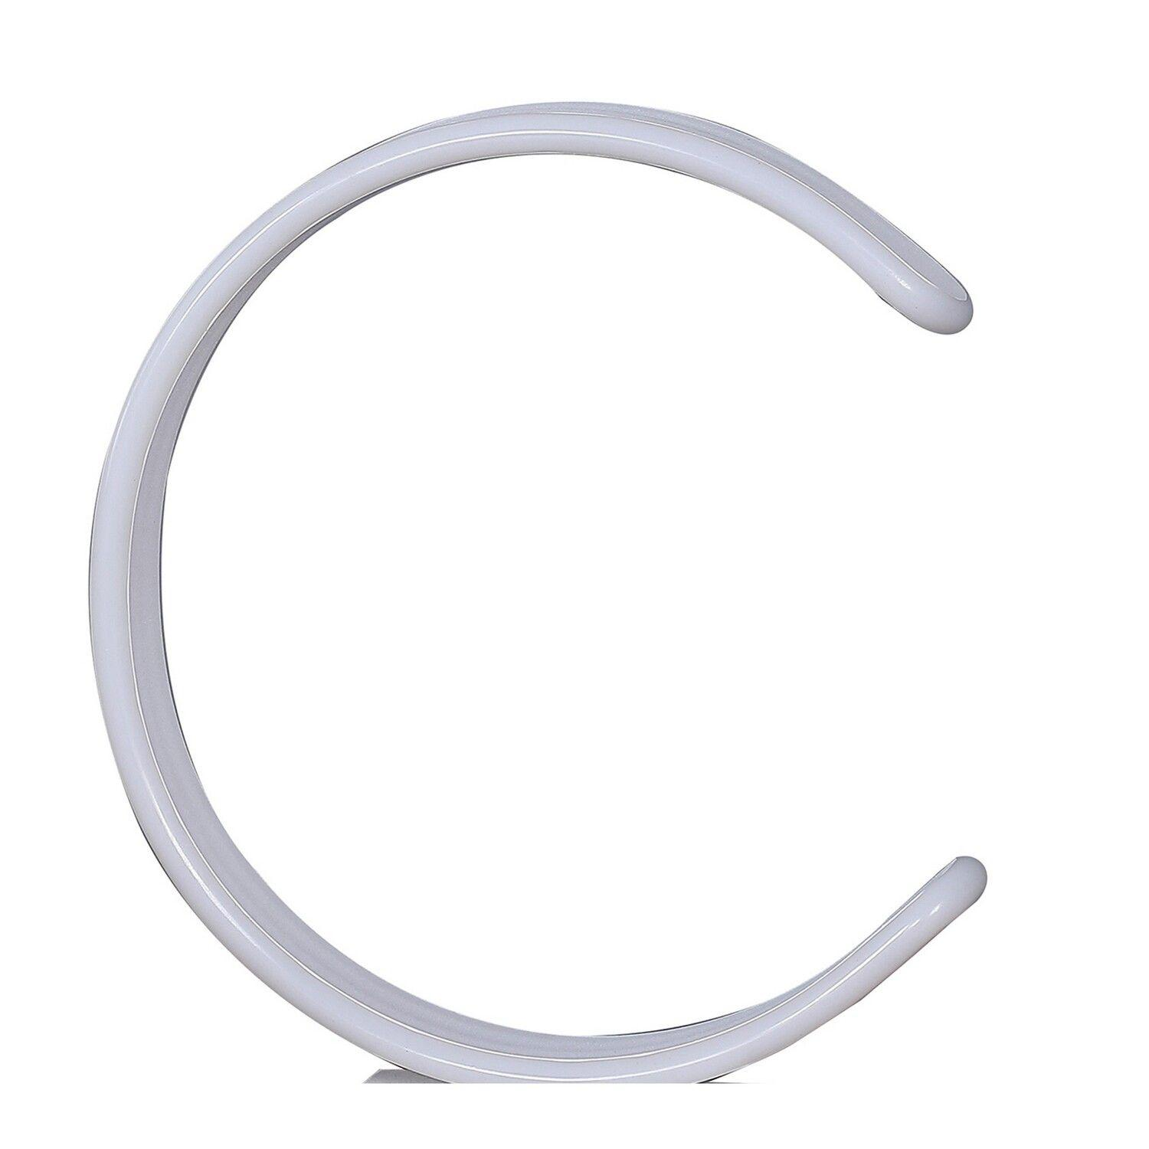
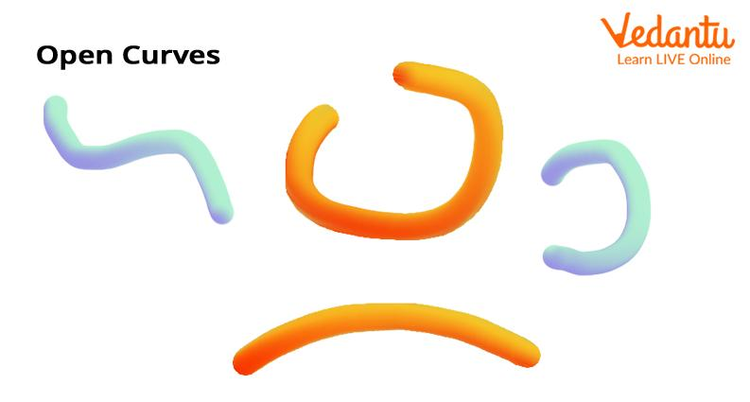
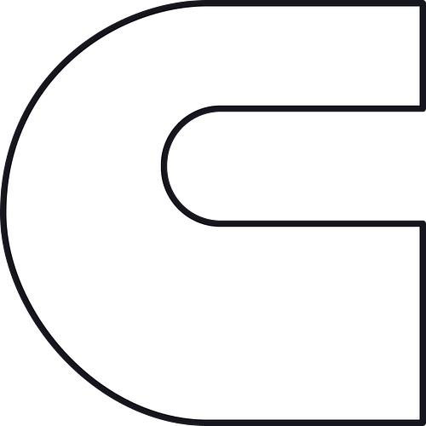
Unlike a circular arc, the curvature does not have to remain constant.

10. Hook-Like Freeform Open Curve
# Source: AI Source: Provided by: [Data Path: Persons Table -> ID Column: 1, Name_En Column: Motasem Essam] -> From: [ChatGPT] on [7/25/2026]
A curve with a hook-like ending or strong change in direction.
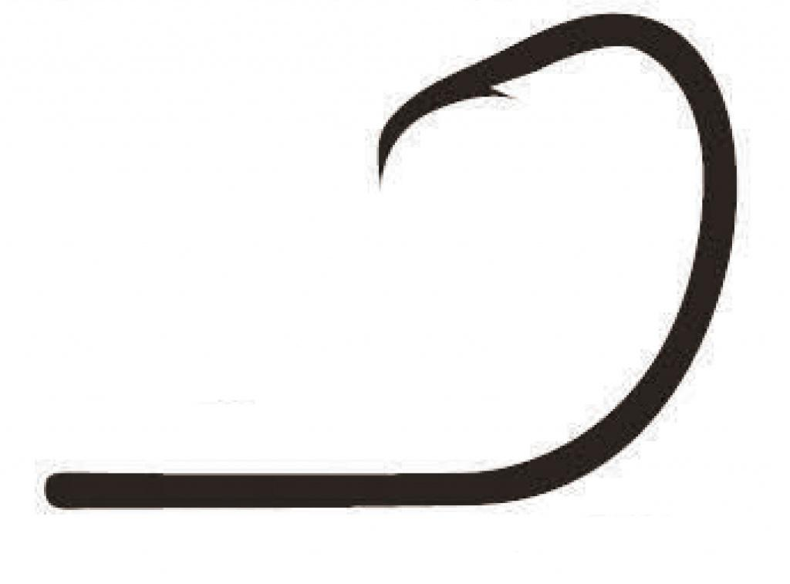
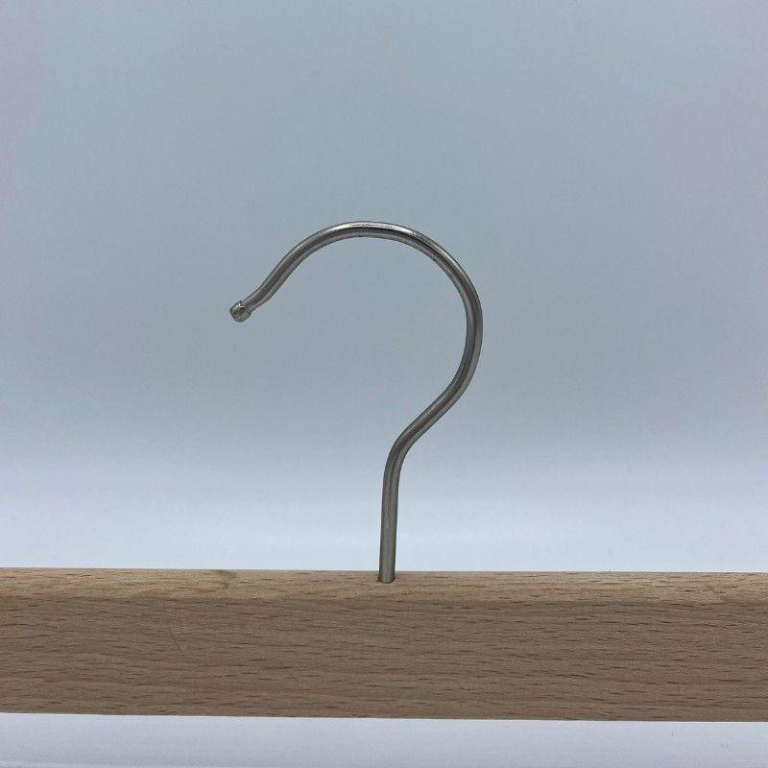
This type is common in artistic and decorative designs.

11. Multi-Bend Freeform Open Curve
# Source: AI Source: Provided by: [Data Path: Persons Table -> ID Column: 1, Name_En Column: Motasem Essam] -> From: [ChatGPT] on [7/25/2026]
A curve with several changes in bending direction.
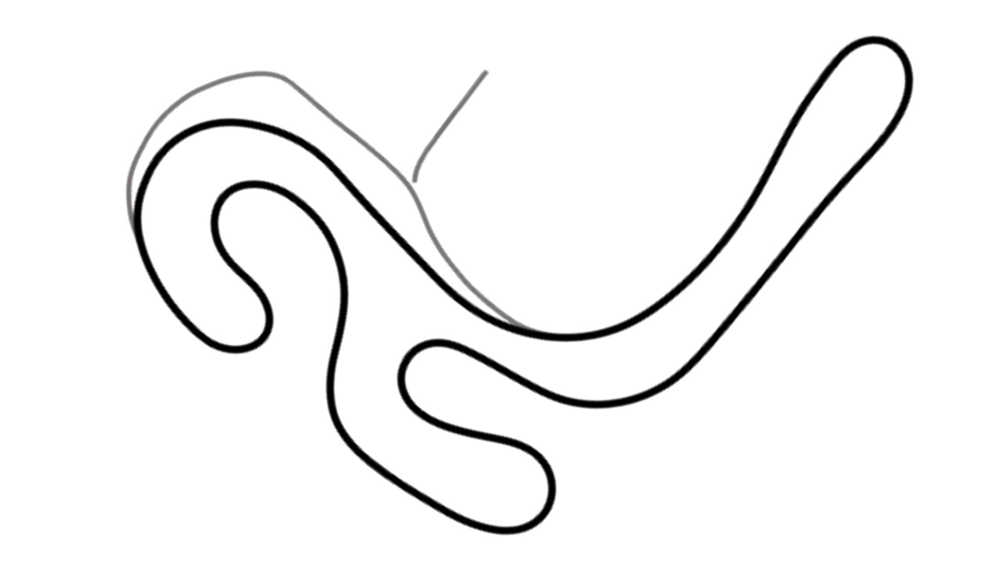
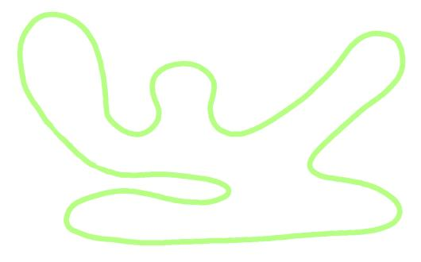
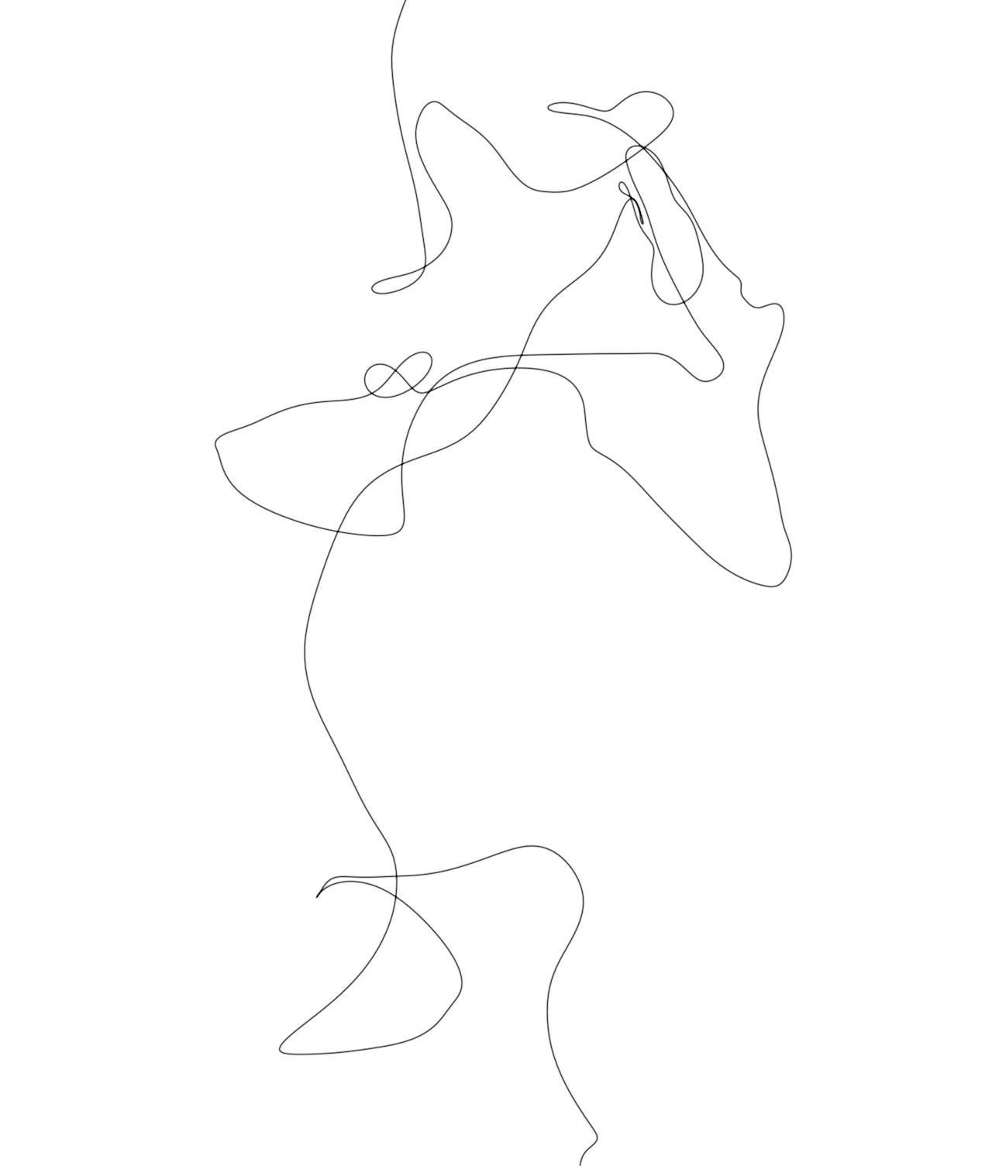
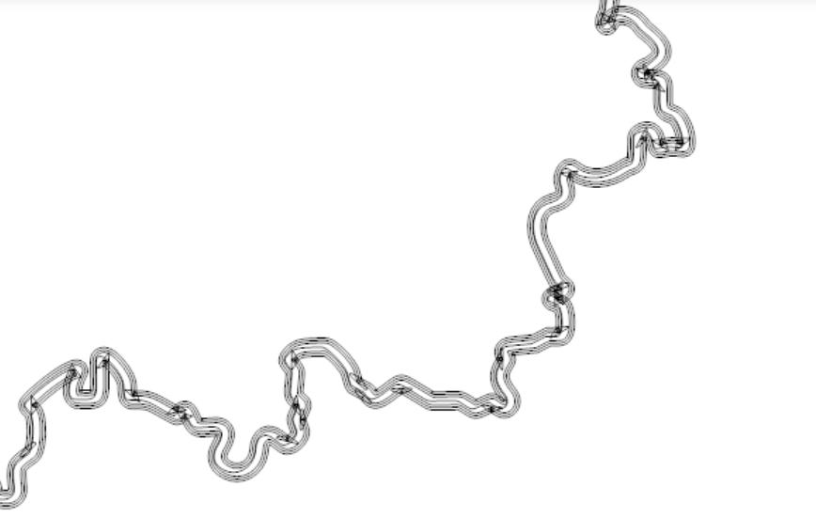
The curvature can change continuously throughout the curve.

12. Artistic Freeform Open Curve
# Source: AI Source: Provided by: [Data Path: Persons Table -> ID Column: 1, Name_En Column: Motasem Essam] -> From: [ChatGPT] on [7/25/2026]
A freely created curved path primarily intended for visual or artistic design.
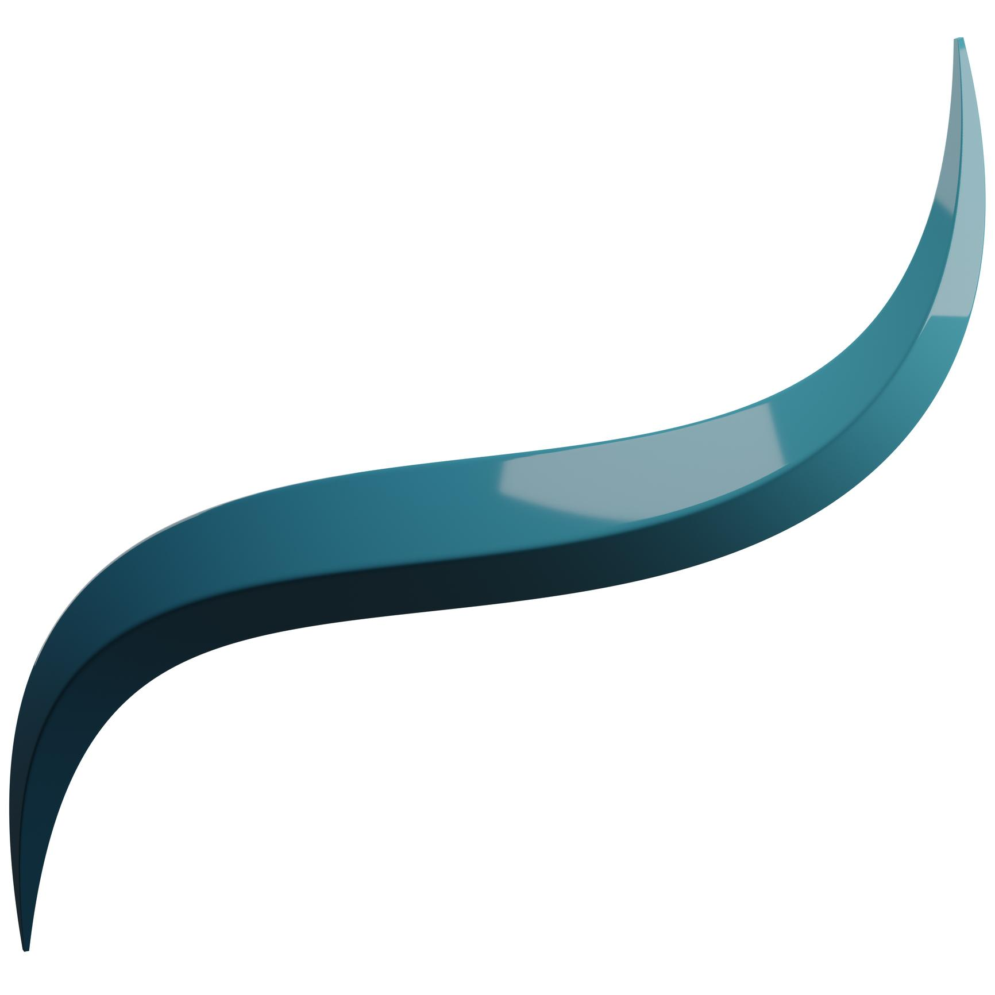

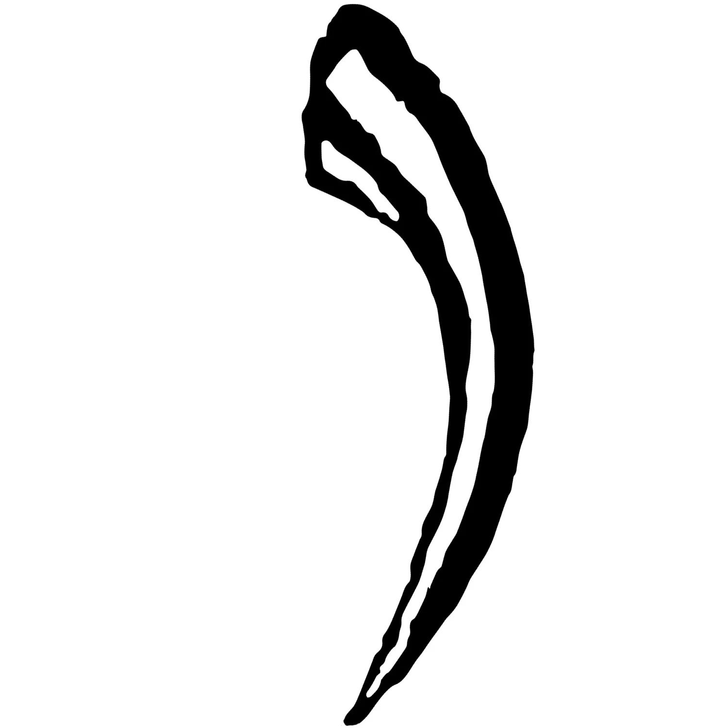
It may combine smooth bends, waves, loops, and other freely controlled features.

Freeform Open Curve vs. Organic Open Curve
# Source: AI Source: Provided by: [Data Path: Persons Table -> ID Column: 1, Name_En Column: Motasem Essam] -> From: [ChatGPT] on [7/25/2026]
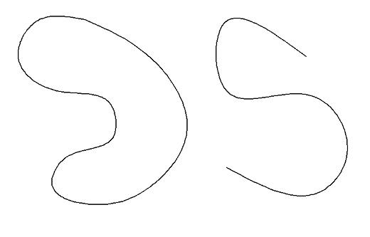
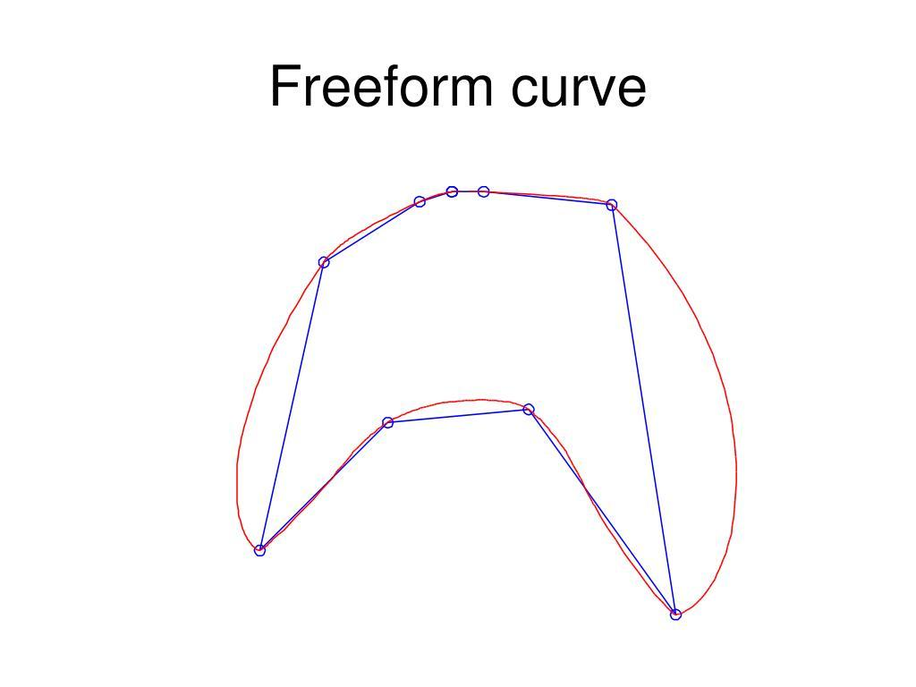
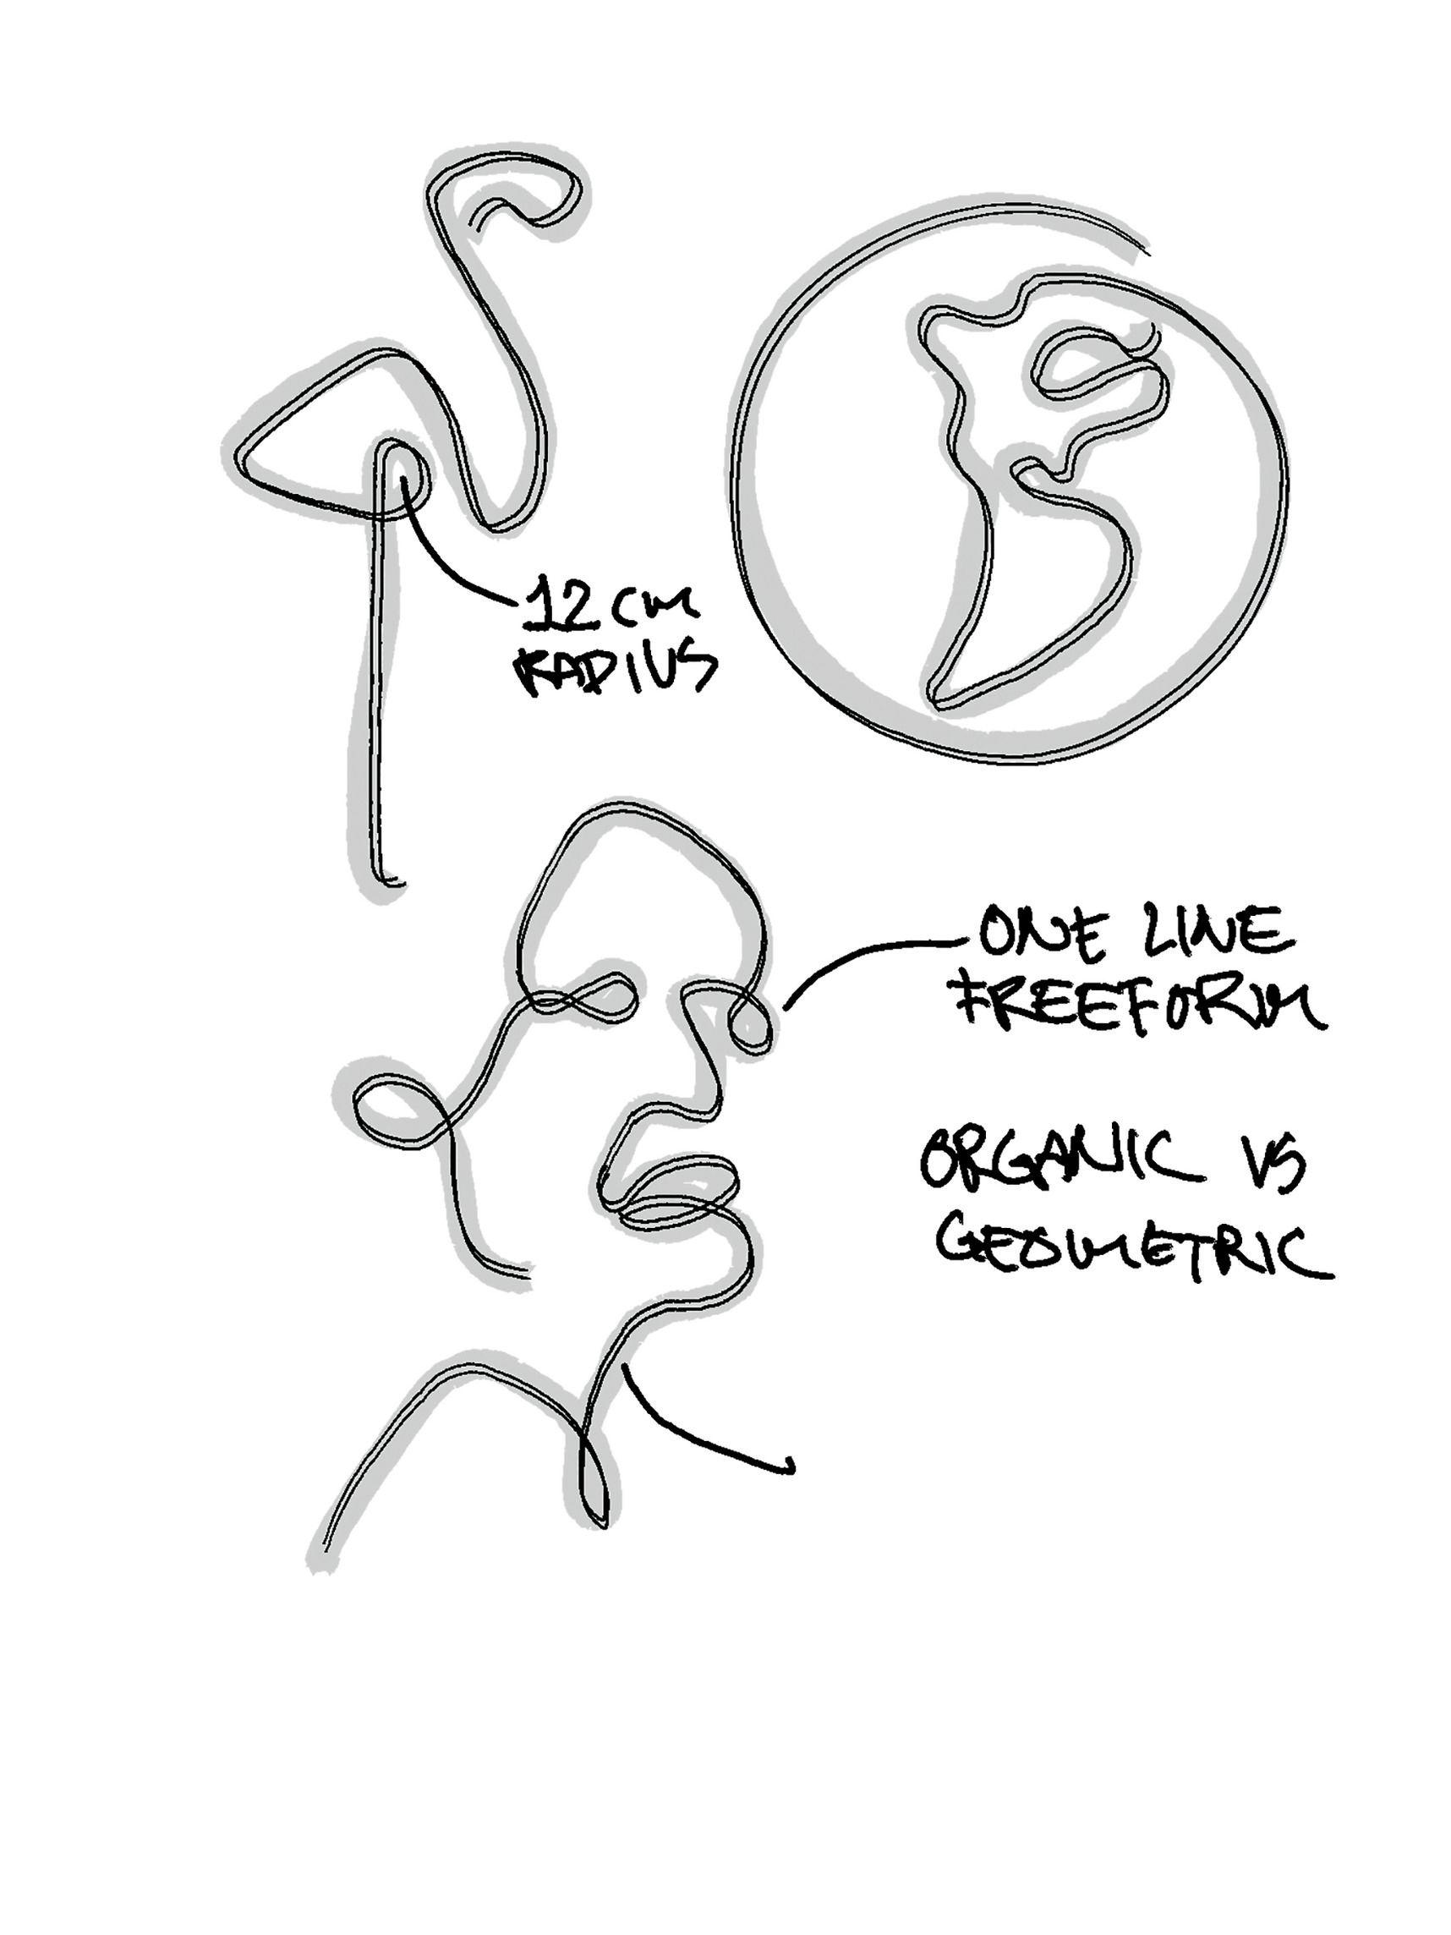
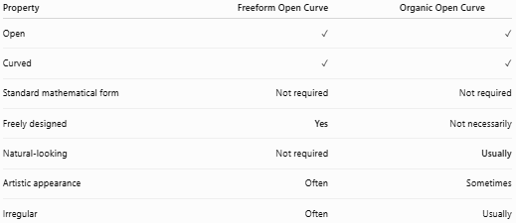
Property | Freeform Open Curve | Organic Open Curve
Open | ✓ | ✓
Curved | ✓ | ✓
Standard mathematical form | Not required | Not required
Freely designed | Yes | Not necessarily
Natural-looking | Not required | Usually
Artistic appearance | Often | Sometimes
Irregular | Often | Usually
Main distinction
$$\boxed{\text{Freeform}=\text{Freely Designed}}$$
while:
$$\boxed{\text{Organic}=\text{Natural-Looking}}$$

Freeform Open Curve vs. Wavy Open Curve
# Source: AI Source: Provided by: [Data Path: Persons Table -> ID Column: 1, Name_En Column: Motasem Essam] -> From: [ChatGPT] on [7/25/2026]
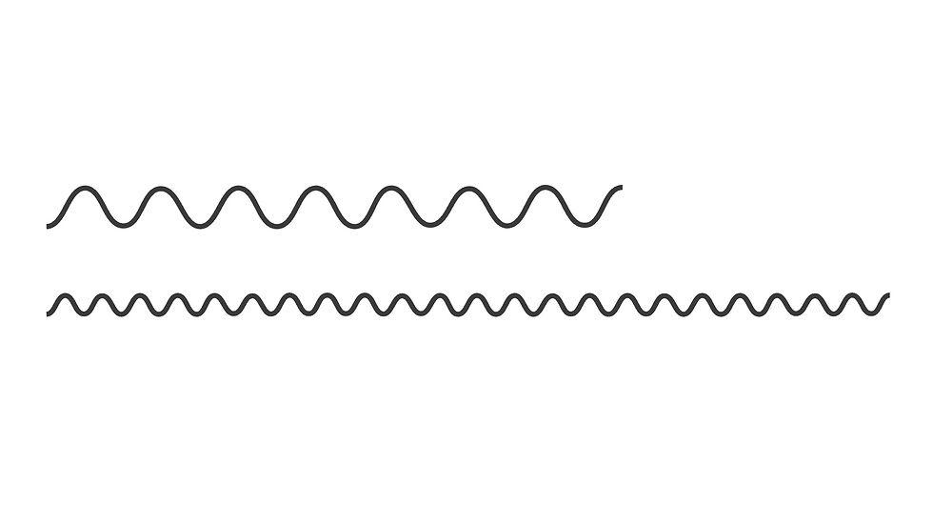
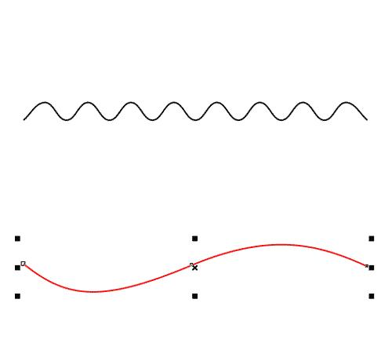
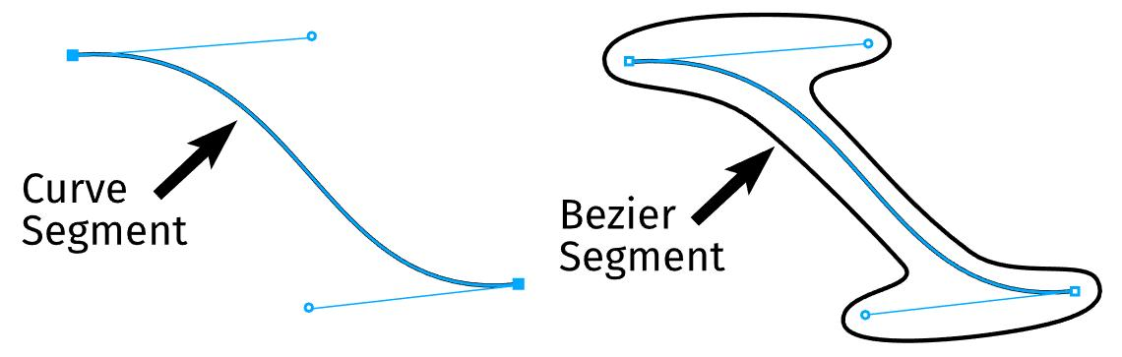
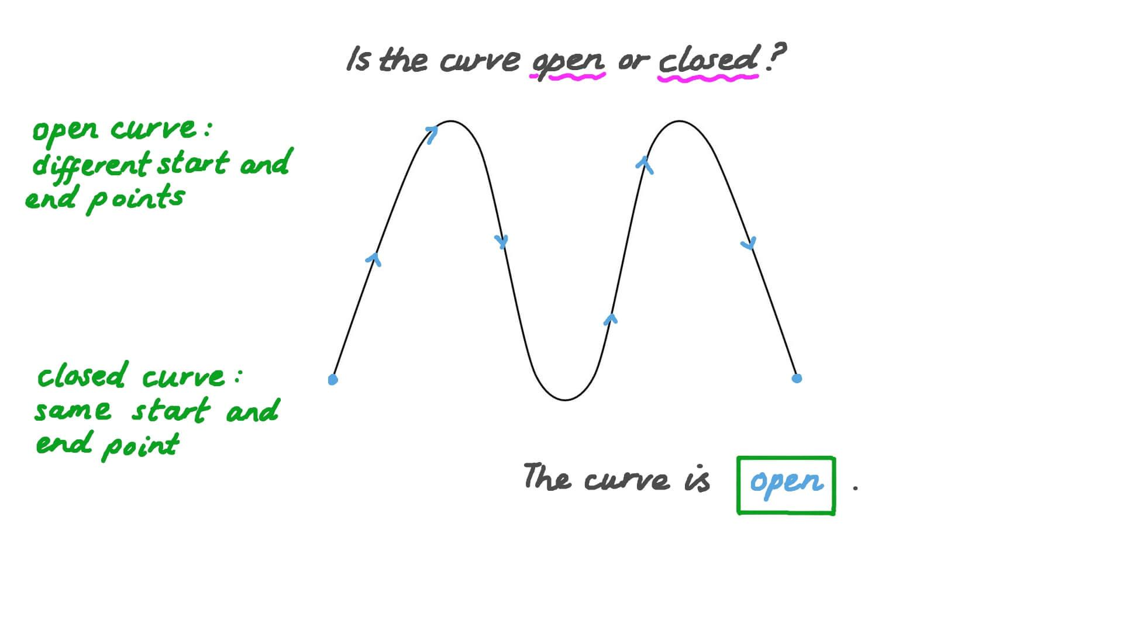
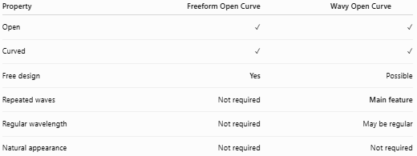
Property | Freeform Open Curve | Wavy Open Curve
Open | ✓ | ✓
Curved | ✓ | ✓
Free design | Yes | Possible
Repeated waves | Not required | Main feature
Regular wavelength | Not required | May be regular
Natural appearance | Not required | Not required
A freeform curve can be wavy, but not every freeform curve is wavy.

Freeform Open Curve vs. Geometric Open Curves
# Source: AI Source: Provided by: [Data Path: Persons Table -> ID Column: 1, Name_En Column: Motasem Essam] -> From: [ChatGPT] on [7/25/2026]
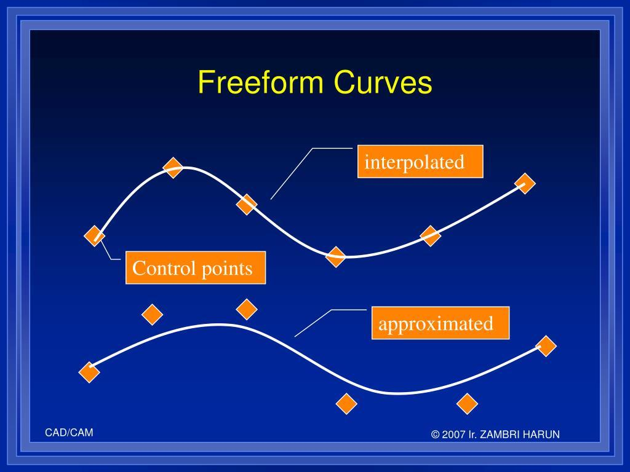
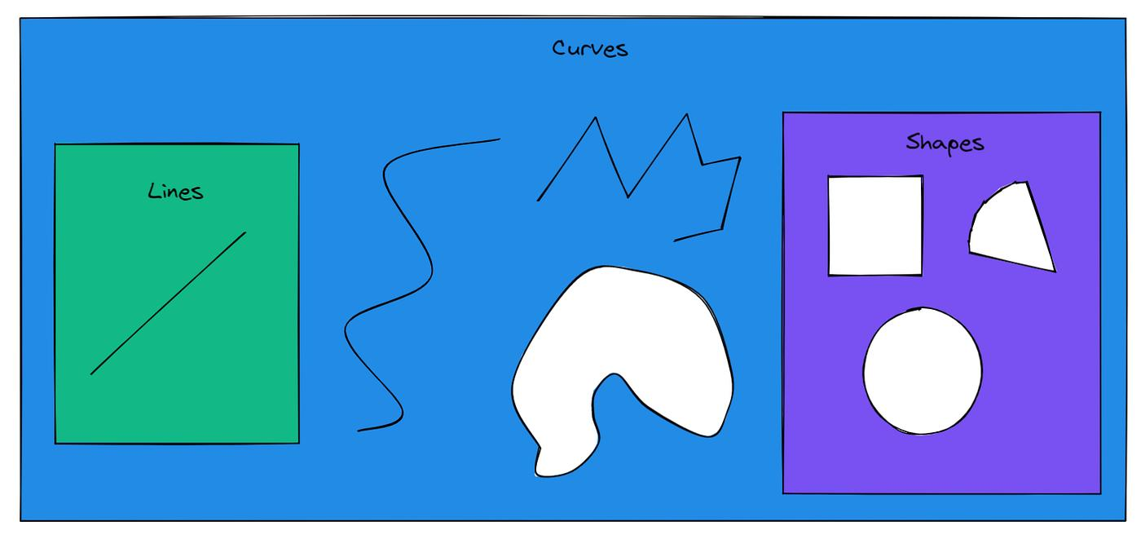
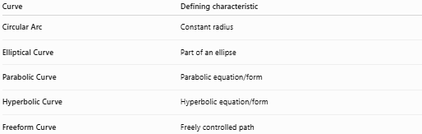
Curve | Defining characteristic
Circular Arc | Constant radius
Elliptical Curve | Part of an ellipse
Parabolic Curve | Parabolic equation/form
Hyperbolic Curve | Hyperbolic equation/form
Freeform Curve | Freely controlled path

Key Points
# Source: AI Source: Provided by: [Data Path: Persons Table -> ID Column: 1, Name_En Column: Motasem Essam] -> From: [ChatGPT] on [7/25/2026]
A Freeform Open Curve is:
$$\boxed{\text{Open}+\text{Curved}+\text{Freely Designed}}$$
It:
- Has two endpoints.
- Does not form a closed boundary.
- Is not restricted to a standard geometric curve.
- Can have continuously changing curvature.
- Can be smooth, irregular, wavy, spiral-like, or multi-bend.
- Can be symmetric or asymmetric.
- Can be artistic or design-oriented.
- Does not enclose an area by itself.

Conclusion
# Source: AI Source: Provided by: [Data Path: Persons Table -> ID Column: 1, Name_En Column: Motasem Essam] -> From: [ChatGPT] on [7/25/2026]
Freeform Open Curves are open curved shapes whose paths are freely designed rather than determined by a specific standard geometric form. They are broader than wavy, organic, or spiral-like curves because those characteristics can all occur within a freeform curve. The key defining property is freedom of shape rather than a particular mathematical or natural pattern.

